e urnciai Hublicatio

n International Association of Security Professionals

April 2007

[www.aloa.org](http://www.aloa.org)

PLUS!

Greg Perry Reuiews Marks Hi-Security Products

**\*\*\*\*\*\*\*\*\*\*\*\*\*\*\*gC(_l** 3.DIGIT 303 BRECK H. CAMP CML PO BOX 47070 ATLANTA GA 30362-0070 I. .11.11

The Rrt of Persuasion and More!

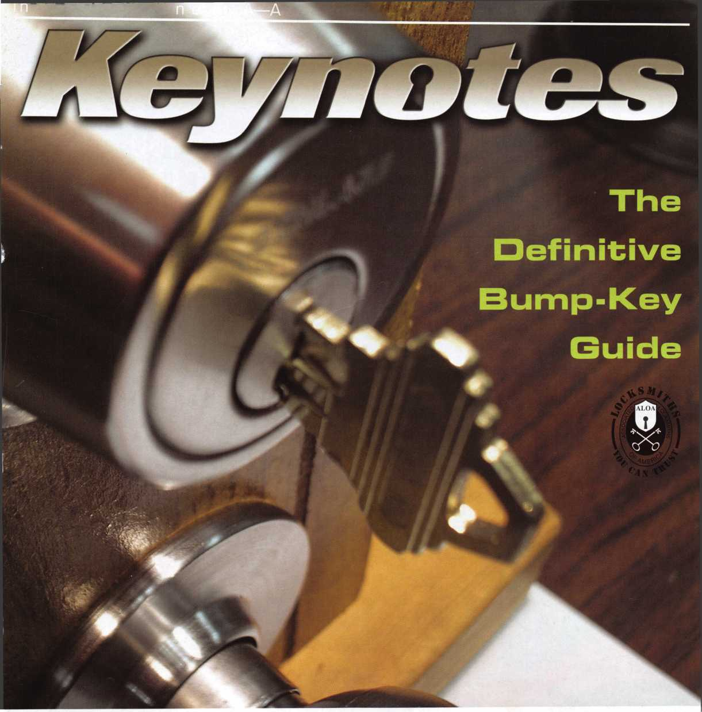

**LOCKSMITHS**

OUR STAND

**WE’RE IN BUSINESS TO HELP YOU**

**REDUCE DOWNTIME**

Commercial vehicle insurance designed to help you get back on the road.

When your vehicle is out of business, so are commercial vehicle insurance as well as other you. That's why Allstate provides fast and fair insurance products designed to help keep your

claim service. Your local Allstate agent offers business in the race. Are you in Good Hands®?

1-888-322-3078

CALL NOW TO SPEAK TO AN ALLSTATE AGENT NEAR YOU,

A

m

Allstate

*iinmn*

v v ~ * ■■ 4-jt- "

**Subject to availability and qualifications. Allstate insurance Company and Allstate Indemnity Company, Northbroqk, IL. Allstate County Mutual Insurance Company, Irving, TX. Allstate New Jersey Insurance Company, Bridgewater NJ. The "Cupped Hands" logo is a registered service mark and "Our Stand" is a service mark of Allstate Insurance Company. NASCAR**"5 **is a registered trademark of the National Association for Stock Car**

Auto Racing, Inc. © 2007 Allstate Insurance Company, Northbrook, IL.

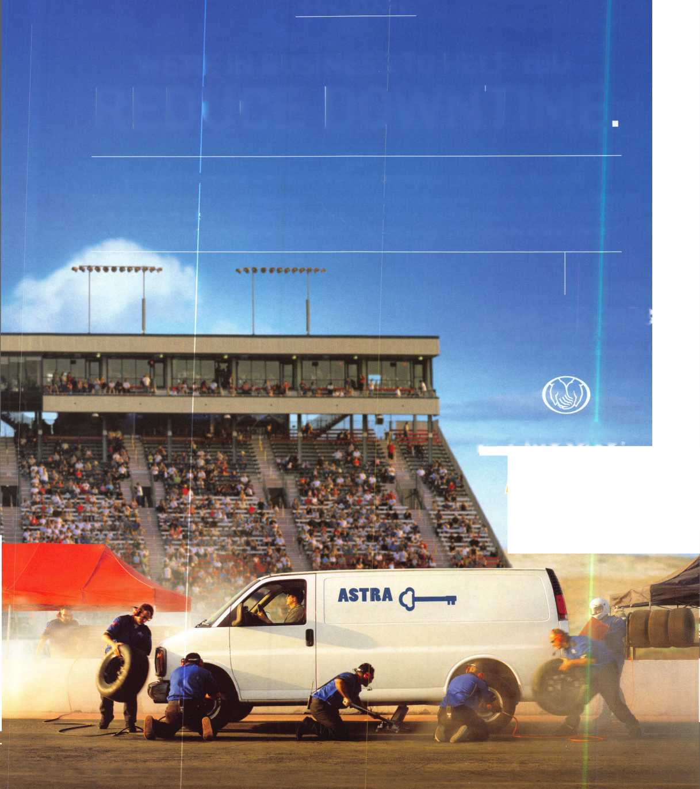

A Name You Know

As a business owner, you know the importance of a  
good name. Your name is your reputation. Your name  
stands for all that you offer in products and services.  
It’s a symbol of who you are. So, we thought you  
might like to know that Allstate, the name you know  
for insuring your personal vehicle and your home,  
also offers a business auto policy to help protect vehi-  
cles used in your locksmith business.

The following are coverages typically included in  
our business auto policy that might be important to  
you as a business owner:

Business Auto Liability coverage

* Higher limits up to $2,000,000 per occur-  
  rence.
* Protects you if you are legally responsible  
  for injuries and damages arising out of  
  the ownership, maintenance, or use of  
  business vehicles.
* Cost is based on several factors, includ-  
  ing garage location, type and use of vehi-  
  cle, and the violation and accident activi-  
  ty of your drivers.
* Additional Insured coverage may be  
  required when you contract with govern-  
  mental agencies or bid on local  
  commercial jobs.
* Generally not available on a personal  
  auto policy.
* Usually is no charge to add an insured to  
  a Commercial Auto policy.

Hired Auto coverage

* Provides liability coverage for those  
  vehicles you rent, hire or borrow for  
  business use.
* The premium for hired auto liability  
  coverage is based on the estimated  
  annual rental cost.
* Tools and Special Equipment
* Provides protection to permanently  
  attached equipment on your vehicle.
* You will need to let your agent know the  
  value of the equipment to include in the  
  cost of the vehicle.

You’re good at your business. Your insurance com-  
pany should be the same way.

Contact an Allstate agent to discuss your business  
auto insurance needs. To be referred to an agent,  
please call 800.859.0247 or email  
[abisO@allstate.com](mailto:abisO@allstate.com).

Subject to availability and qualifications. Insurance coverage is  
subject to policy terms.

Allstate Insurance Company

Allstate Indemnity Company Northbrook, IL

Allstate County Mutual Insurance Company

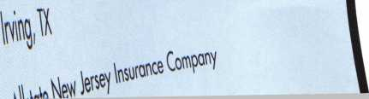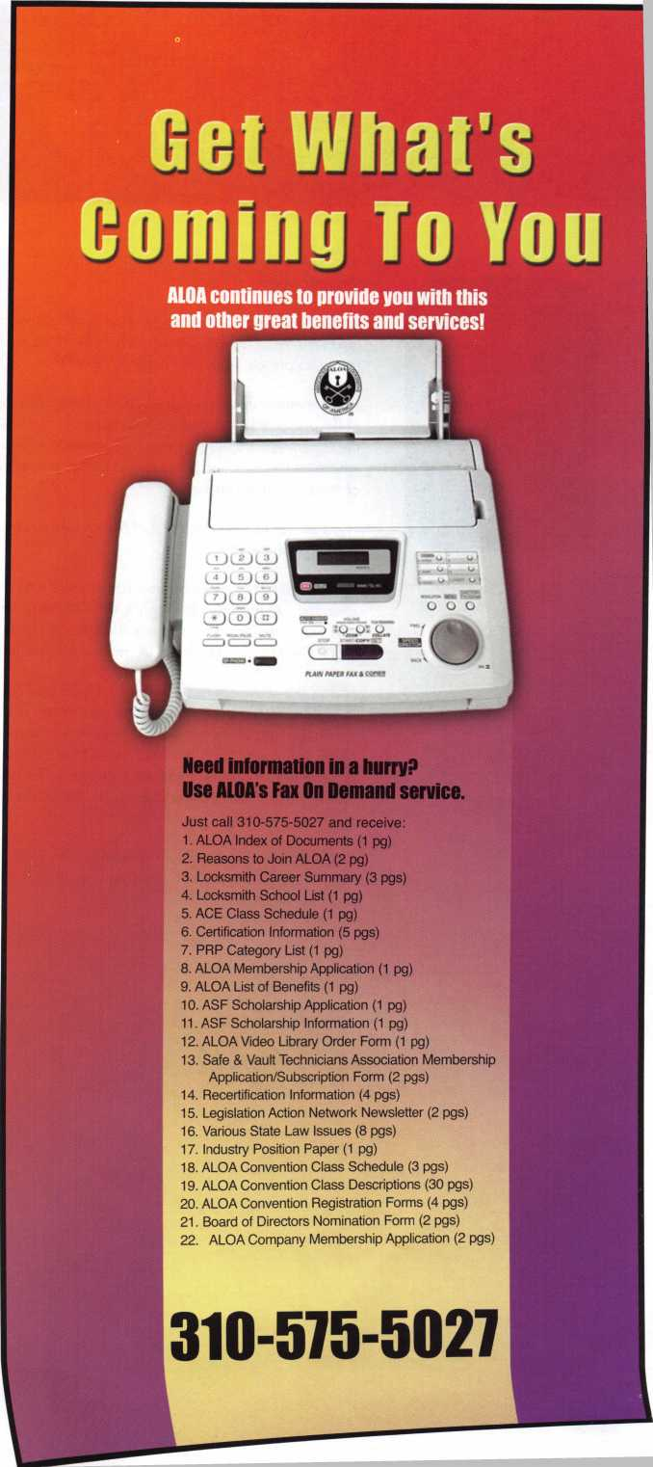

presidential

viewpoint

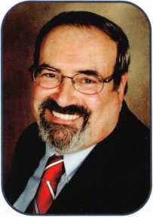

Dear Members,

Visiting our chapter in Japan for their tenth anniversary celebration was a wonderful experience. The chapter had a  
top-notch event featuring education, networking and camaraderie in the form of a great banquet. There were seven  
members present from the Korean chapter showing their solidarity in making ALOA in Asia a quality experience.

At the membership meeting, ALOA presented the Japanese Chapter with a plaque commemorating the occasion.

I also presented plaques for outstanding service to ALOA and their respective chapters to Mr. Hidetomo Kimura of  
the Japanese Chapter (His magical presence is felt in all of the chapter's works.) and one to Mr. Chel Ho Shin,  
whose ceaseless energy and enthusiasm is propelling the Korean Chapter into the future. We can truly be proud  
of these two fine chapters.

I had left for Japan on the first of March and returned home on the sixth. Then, with a one day breather, I left for  
SAVTA on the eighth.

The SAFETECH Convention and Trade Show was great! The classes, trade exhibit and factory tours were all well  
attended. At the Thursday night's Kick-Off Party, sponsored by Sargent and Greenleaf, the annual auction was held  
and was a terrific success. I attended the SAVTA Board Meeting and General Meeting at which our own Bill Smith,  
North Central director of ALOA, received a special award and a lifetime membership to SAVTA.

Friday, the show opened. Friday night, LSI and Lockmasters sponsored a trip to their facilities where we were treated  
to some fantastic barbeque and entertainment. The museum and B-B-Q provided an opportune chance to combine  
education and pleasure. Saturday night was a special time. S&G took everyone to a famous race track, the Red  
Mile. There we saw a presentation, a brief history of S&G's one hundred and fifty years in our industry. Ron Snive-  
ly, President of SAVTA, and I each presented Sargent and Greenleaf with a commemorative plaque in honor of their  
anniversary. Then, after a superlative dinner, we were mesmerized by a hypnotist who showed the members of the  
audience their freer side.

At this time we have multiple candidates for all of the positions that are to be voted on ,both presidential and directo­rial. I applaud those who are so giving of their time and efforts to step up and run for the positions of president and directors of the board.

Take 'er easy! Sincerely,

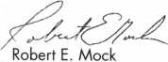

Keynotes

April 2007

LOUISIANA-MISSISSIPPI  
LOCKSMITH ASSOCIATION

Convention, Classes, and Dealer Show  
Paragon Casino and Resort  
Marksville, LA  
April 26, 27, and 28, 2007

Cost $150.00 for all classes you want to take.  
Includes Breakfast on Saturday

Check out our web site for information  
[www.loumiss.org](http://www.loumiss.org)

feat

BUMP-KEYS 2007

10

Things That Go BUMP in the Night (or Day)

Read the definitive guide to the bump-key issue.

by Jim Hancock

**14**

Member Spotlight:

Guy Gabai - S.O.S. Locksmith Corp.

S.O.S. has been servicing New York for over 30 years. Find out why.

22

It's in the Fingers - Follow-up Article

Read Greg Perrys follow-up article to last month's Something Old, Something New.

by Greg Perry CML., CPS

**30**

The Art of Persuasion

Are you familiar with the art of persuasion? Find out how to get the edge you need to reach your goals.

by Paul Endress

**Departments**

u

r e

s

**AD INDEX**

**Allstate Inside Front Cover**

**Fax on Demand 1**

**LMLA 3**

**ALOA 2007 7**

**Cal-Royal 15**

**Letro Truck 16**

**Ben Jim 17**

**PBP 18**

**Safetech 2008 19**

**Clearstar 20**

**IR 21**

**Turn 10 23**

**DKS 25**

**ALOA Golf Tournament 27**

**CSPEC 28**

**ALOA Be Sure To Vote 29**

**ALOA Member Recruitment 31**

**Ultralift 33**

**A&B 40**

**Locksmithing UNL 40**

**Coast Safe & Lock 40**

**HL Flake 41**

**ALOA President's Club 42**

**North Bennet Street School 43**

**Jet Hardware 44**

**Door Jam Armor Inside Back Cover**

**CCL Back Cover**

|  |  |  |  |  |  |  |  |
| --- | --- | --- | --- | --- | --- | --- | --- |
| Presidential Viewpoint 2 | Executive  Applicants .... | 5  6 | Calendar  Core | 8  9 | Classified  Associate | 34 | Legislative 38 |
|  |  |  |  |  | Members | 36 |  |

u r N EW w p A c ; * „

Visit

o

executive



Volume 53, Issue 4

Additional contact information for the ALOA Board is available on the ALOA website—  
[www.aloa.org](http://www.aloa.org) or by contacting the ALOA office at 3500 Easy Street; Dallas, TX 75247;  
(800)532-2562; FAX (214)819-9736; e-mail [aloa@aloa.org](mailto:aloa@aloa.org).

Editor & Director of Creative Services

Betty Southerland [betty@aloa.org](mailto:betty@aloa.org)

Advertising Sales

Kim Hammond voice: 817-645-6778

Fax: 817-645-7599 e-mail: [adsales@aloa.org](mailto:adsales@aloa.org)

Executive Director

Charles W. Gibson, Jr., CAE [charlie@aloa.org](mailto:charlie@aloa.org)

Associate Executive Director

David Lowell, CML, CMST [david@aloa.org](mailto:david@aloa.org)

Convention & Meetings Manager

Jo Anne Mims [joanne@aloa.org](mailto:joanne@aloa.org)

Operations/Membership Manager

Mary May [mary@aloa.org](mailto:mary@aloa.org)

Director of IT Operations

Greg K. Jackson [greg@aloa.org](mailto:greg@aloa.org)

Comptroller

Kathy Romo [kathy@aloa.org](mailto:kathy@aloa.org)

Membership Development Manager

Ellen R. McEwen [ellen@aloa.org](mailto:ellen@aloa.org)

Membership Coordinator Shelly Jett

Convention & Meetings Assistant Karen Lyons  
PRP/Education Coordinator Shelley Melton

Mail Room Coordinator Kevin Wesley

Graphic Designer Margarita Garza

Accounting Coordinator Joyce Nixon

Executive Assistant Sue Langford

Assistant Education Manager Bob Stafford, CML  
Legislative Manager Tim McMullen

Contributors

Jerome Andrews, CML  
Paul Chandler, CRL  
Claire Cohen, CML  
Brian Costley, CML, CMST  
Eric Costley, CRL

Ray D'Adamo, CML Billy Edwards, CML Dan Graffeo, CRL,CMST Jim Hancock, CPL Jeff Nun berg, CML, CMST

Randy Simpson, CML, CPP Robert Stafford, CML Dave Thielen, CML Greg Perry, CML,CPS

Tom Seroogy

Charles Stephenson, CPS

Dennis Watanabe, CML, CMST

Mission Statement: The Associated Locksmiths of America, Inc. is dedicated to enhancing the professionalism, education and ethics among  
locksmiths and those in related sectors of the physical security industry. With approximately 10,000 members in the United States, Canada and the  
freeworld, ALOA is poised to help members obtain the knowledge, the strength, and the confidence to perform their role in the physical security field  
with pride and dignity. But it is only through active involvement and participation that ALOA can fully achieve its potential—and can help members to  
achieve theirs.

Policies: Keynotes® is the official publication of the Associated Locksmiths of America, Inc. (ALOA). Keynotes® acts as a moderator without approving,  
disapproving, or guaranteeing the validity or accuracy of any data, claim, or opinion appearing under a byline or obtained or quoted from an acknowl-  
edged source. The opinions expressed by the authors do not necessarily reflect the official views of ALOA. Also, appearance of advertisements and  
new products or service information does not constitute an endorsement of products or services featured by the Association. The Association does not  
accept responsibility for the inaccuracy of any data, claim, or opinion appearing in this publication, due to typographical errors on the part of the  
authors, Association staff or its agents.

Editor's Note: This publication is designed to provide accurate and authoritative information in regard to the subject matter covered. It is provided  
and disseminated with the understanding that the publisher is not engaged in rendering legal or other professional services. If legal advice and other  
expert assistance is required, the services of a competent professional should be sought.

Authors' Payment: Payment for eligible submissions to Keynotes will be based on the following criteria: topic, time spent and past contributions. Authors who  
regularly submit to Keynotes® are generally paid a higher rate. The latter is especially true of authors who write to fit specific editorial needs and submit said copy  
by Keynotes® deadlines. As a general guideline: Average payment for a 750 word, business or 'light' technical article would be $200. Payment for a 1500 word  
article involving significantly higher time and research efforts would be $400.

Payment will not be offered for articles submitted by ALOA employees or members of the ALOA Board of Directors (unless material is of a technical  
nature), nor for articles submitted by a company that promote that company's products or services. ALOA reserves the right not to pay for articles sub-  
mitted by an individual(s) that promote a particular company's products or services.

Disclaimer: The Associated Locksmiths of America, Inc., (ALOA), reserves the right to refuse any article for any reason. Additionally, ALOA reserves  
the right to edit, amend or modify any article submitted for publication in order to preserve technical accuracy, clarity, fairness or grammatical correct-  
ness. ALOA will make the best efforts to notify the author of any changes. The extent of ALOA's liability for any article or information contained there-  
in will be a notice of correction or retraction in the next possible issue.

Keynotes® (ISSN 0277 0792) is publishec  
3500 Easy St., Dallas, TX 75247-6416.  
members-$ 15.00 per year. Periodical class  
TX 75247-6416. © Copyright 2003, All  
written permission of the publisher.

i monthly except for the combined June/July issue by The Associated Locksmiths of America, Inc., Telephone: (214) 819-9733; FAX (214) 819-9736; e-mail [aloa@aloa.org](mailto:aloa@aloa.org). Subscription rates for postage paid at Dallas, Texas. POSTMASTER: Send address changes to: Keynotes, 3500 Easy St., Dallas, rights reserved. No part of the contents may be reproduced or reprinted in any form without prior

President

Robert Mock  
(856) 8630710  
presiden t@aloa. org

Secretary

John Soderland, CML, CMST  
(414) 327-5625  
secretary@aloa. org

Directors, Northeast

Tom Foxwell  
(410) 206-5772  
[nedirecfor@aloa.org](mailto:nedirecfor@aloa.org)

Robert D. DeWeese, CML, CPS  
(410) 2850101  
[nedirector@aloa.org](mailto:nedirector@aloa.org)

Directors, Southeast

Tom Gillingham, Jr., CML, CPS  
(615) 2640747  
sed i rector@aloa. org  
Ken Kupferman, CML, CPS  
(813) 232-7600  
sed i rector@a loa. org

Director, North Central

William Smith, RL  
(920) 893-5282  
Guy Spinello, RL  
(815) 394-1000  
ncd i rector@a loa. org

Director, South Central

CD Lipscomb, CML, CPS  
(903) 874-3522  
scdirector@aloa .org

Directors, Southwest

Greg Parks, CRL  
(858) 271-1155  
swdi rector@aloa. org

Julie McCluney, CRL  
(714) 636-5652  
s wd i rector@a loa. org

Director, Northwest

Keith E. Whiting, CML, CFL  
(360) 601-5656  
n wd i rector@aloa .org

Director, International

Hans Mejlshede, CML  
(453) 539-3939  
eurd i rector@a loa. org

Director, Associate

Dan Floeck  
(800)231-4105

asd i rector@a loa. org

Trustees

[trustees@aloa.org](mailto:trustees@aloa.org)

Randy Simpson, CML, CPP  
(281) 240-5959

JohnJ. Greenan, CML, CPS  
(773) 486.2030

William Young, CML, CPS  
(610) 647-5042

Past Presidents

2003-2005 William Young, CML, CPS  
2001-2003 Randy Simpson, CML  
1999-2001 John Greenan, CML, CPS  
1997-1999 Dallas C. Brooks  
1995-1997 David Lowell, CML, CMST  
1993-1995 Breck Camp, CML  
1991-1993 Henry Printz, CML  
1989-1991 Evelyn Wersonick, CML, CPS  
1987-1989 Leonard Passarello, CPL  
1985-1987 Joe Jackman, CML  
1983-1985 Stanley Haney, CPL  
1981-1983 Louis LaGreco, CPL  
1979-1981 John Kerr, RL  
1977-1979 Clifford Cox, CML  
1974-1977 Charles Hetherington  
1972-1974 Gene Laughridge  
1970-1972 William Dutcher, RL  
1968-1970 Constant Maffey, RL  
1966-1968 Harold Edelstein, RL  
1964-1966 William Meacham  
1962-1964 Robert Rackliffe, CPL  
1960-1962 Edwin Toepfer, RL  
1956-1960 Ernest Johannesen

Keynotes • April 2007

AZ

**GA**

Warren

Greenville

**Mesa**

Sharon Misseldine

Sponsor: Joson Stewart

**CA**

Bakersfield

David V. Fuentes

**Redwood City**

Gary D. Hogan

Sponsor: Frederick P. Collier **Solana Beach**

Charles Shapiro

**Ventura**

Michael Uchuion

Sponsor: David M. Lowell CML, CMST

***CO***

Pueblo West

James A. Hinojosa Sr

Sponsor: John L. Shandy

CML

**CT**

**Branford**

Richard G. Weiss CML, CPP

FL

**Ocoee**

Thomas G. Tusing

Sponsor: Steven R. Myslik

CRL

Orlando

Timothy Kasper

Sponsor: Ken Kupferman

CML,CPS

**Winterville**

Herman T. Fields

IA

**Bettendorf**

Jeff L Kling

IL

**East St Louis**

Philip Boyajian

IN

Cicero

James K. Ashley III

MD

Bowie

Duane A. Sewell

Sponsor: David M. Troiano **Reisterstown**

C Brandon Baird

Sponsor: Robert D. DeWeese CML**, CPS**

Woodwardville

John R. Yates III, CPL

Sponsor: Robert D. DeWeese CML, CPS

Ml

Canton

Edwin F. Edmunds

Sponsor: Charles E. Batcke CRL**,** CPS

**Grand Blanc**

Andrew H. Tenneriello

Sponsor: Jeremy M. Ameen

John Shamass

Sponsor: John K. Hubei CML

MN

**Saint Paul**

Jay D. Hanson

NC

Charlotte

Craig Barrett

Sponsor: Robert H. Stafford CML

NY

**Brooklyn**

Itzhak Hizami

New York

Dan Basovitch

OH

**Cortland**

Dennis C. Thomas CRL

PA

**Allison Park**

Patrick J. Fontana

Sponsor: Raymond C. Vogel **Harrisburg**

Matthew S, Leaver

Sponsor: Jerry J. Arnette **Pittsburgh**

Warren J. Freiss

sc

**Anderson**

Herbert L. McCrider

P fa apu IC?J l areJ^hedulled clearance as members of ALOA. The names are published for member review and comment within 30 days of this Keynotes issue date respectively to ensun Protests, if any, should be addressed to the Membersh,p Department and must be signed. Active Membership applicants (a) have worked in the induXy two or more years. Allied' MeSrship (AL) ap,

Apprentice Membership (AP) applicants have worked in the industry less than two years.

Michael Beckett

**North Augusta**

Victor LaVarnway

TN

**Cookeville**

Randy Gentry

Sponsor: Ernest R. Langley Sr

VA

**Centreville**

John J. Maxvill

**Charlottesville**

Randall S. Johnson

Sponsor: Eugene F. Bellomy

III

WV

**Charles Town**

James E. Rednowers Jr

Sponsor: Robert D. Smith

**Canada**

Vancouver

Yerasimos Catevatis

Sponsor: Michael C. Burns CML

**Great Britain**

Essex

Ricky Price

Sponsor: Jason Dorner **Kenley**

Peter Rigby

Sponsor: Ken Dale

applicants meet standards of ALOA's Code of Ethics, licants are not locksmiths, but work in a security-related field.

Keynotes • April 2007



Start Your Engines!

This year, with a great location and a  
schedule chock-full of exciting classes  
and events, we are pulling out all the  
stops to celebrate the ALOA Convention  
and Security Expo in Charlotte, North  
Carolina.

Having built an international reputation  
among locksmiths as a powerful resource  
to explore industry innovation and form  
industry alliances, ALOA 2007 is the ideal  
place to learn, network or to showcase  
your security-related business on the  
show floor.

This year weve thought of everything  
from an exciting location to a comfort-  
able hotel and a convention center that is  
equipped to handle your every need. The  
exhibit hall promises to be overflowing  
with the latest technology and new mer-  
chandise.

|  |  |
| --- | --- |
| july 22-29, 2007 charlotte, north caroli | na |
| <+ 4 , 5 |  |
| 3  xlOOOr/min  "2 M |  |
|  | 7 |
| ✓ q Al-OA 2°°7 8 | |
| aloa convention and security  51st ANNUAL | expo |

**Don't**

**miss out**

**upcoming events**

**0\***

**Q.**

<

4/18 Doyle University  
Minneapolis, MN  
Doyle Security Products

For more info [www.doylesecurity](http://www.doylesecurity).

com

4/21 VLA Meeting & Class Charlottesville, VA Contact: Elliot Paul Conner email: [va_locksmith@verizon.net](mailto:va_locksmith@verizon.net)

4/26-28 Louisiana-Mississippi Locksmith Association Convention, Classes, & Dealer Show Paragon Casino & Resort Marksville, LA • [www.loumiss.org](http://www.loumiss.org)



5/1 Counter Days • [www.doylesecurity.com](http://www.doylesecurity.com) 5/16 Doyle University Minneapolis, MN Doyle Security Products For more info [www.doylesecurity.com](http://www.doylesecurity.com)

6/6 Counter Days • Minneapolis, MN Doyle Security Products RCI with Mark Schrantz • [www.doylesecurity.com](http://www.doylesecurity.com)

5/4-6 Wyoming Locksmiths Assc. Trade Show Casper, Wyoming Jim O'Grady • 307-234-5932

5/18-20 ELF Convention 2007 • Riga, Latvia European Locksmith Federation Exhibition - Social events -Education [www.elf2007.com](http://www.elf2007.com) • [ruta.reinika@prplus.lv](mailto:ruta.reinika@prplus.lv)

6/20 Doyle University Minneapolis, MN Doyle Security Products For more info [www.doylesecurity.com](http://www.doylesecurity.com)

6/23 VLA Meeting & Class Charlottesville, VA Contact: Elliot Paul Conner email: [vaJocksmith@verizon.net](mailto:vaJocksmith@verizon.net)

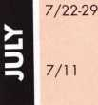

ALOA '07 Convention & Security Expo • Charlotte, NC Associated Locksmiths of America [convention@aloa.org](mailto:convention@aloa.org) • [www.aloa.org/convention](http://www.aloa.org/convention) Counter Days • [www.doylesecurity.com](http://www.doylesecurity.com)

**Z**

o

o

**V)**

9/14-15 Doyle Annual Trade Show & Education • Prior Lake, MN Doyle Security Products Mystic Lake Casino [www.doylesecurity.com](http://www.doylesecurity.com)

**UPCOMING ACE CLASSES**

April 14-15, 2007 April 21,2007 April 26 - 28, 2007

May 5, 2007

May 7 - 12, 2007

May 17-19, 2007

June 9, 2007

June 9-10, 2007

July 14, 2007 July 22-29, 2007

Kansas City, MO • Missouri-Kansas Locksmith Assc. For specific course schedule please contact:

Bob Turner • 816-525-5522

Kearney, NE • Nebraska Chapter of ALOA

Push Button Mechanical Lock Manipulation

Elmer Howard • [safeman@cox.net](mailto:safeman@cox.net) • 402-676-8973

Denver, Colorado • Central & Southern Colorado

Locksmths Association • 9 ALOA Certified Classes

Contact: Barry Meyers, CPL • 303-688-1404

Detroit, Michigan

Locksmiths Security Association

Small Format 1C w/L-38 PRP

Marc A. Dearing, CRL • 810-244-4038

Dallas, Texas • ALOA Training Center

Six-Day Basic Locksmithing Course

ALOA Education • [education@aloa.org](mailto:education@aloa.org)

800-532-2562x104

Dallas, Texas • ALOA Training Center

3-Day Automotive Locksmith Course

ALOA Education • [education@aloa.org](mailto:education@aloa.org)

800-532-2562x104

Birmingham, AL • Alabama Chapter of ALOA Basic Safe Penetration • Dallas Brooks 334-826-8990

Dallas, Texas • ALOA Training Center Keyless Mechanical Lock Servicing w/L20 PRP Push Button Mechanical Lock Manipulation ALOA Education • [education@aloa.org](mailto:education@aloa.org) 800-532-2562x104

Norfolk, Nebraska • Nebraska Chapter of ALOA

Advanced Topics in Master Keying

Elmer Howard • [safeman@cox.net](mailto:safeman@cox.net) • 402-676-8973

Charlotte, North Carolina

ALOA 51 st Annual Convention & Security Expo

70 Full Day Classes • 35 Half Day Classes

& Evening Seminars

ALOA Education • [education@aloa.org](mailto:education@aloa.org)

800-532-2562x101 • [www.aloa.org](http://www.aloa.org)

**UPCOMING PRP Sittings**

4/28/07 Saturday 8:00am • Roseville, Ml • Robert C. Noble, CML

Locksmith Security Association • 810-385-9329

4/28/07 Saturday 6:00pm • Denver, CO • Barry Meyer, CPL

Central & Southern Colorado Locksmiths Association 303-688-4104 • [acomal@gwest.net](mailto:acomal@gwest.net)

5/12/07 Saturday 1:00pm • Dallas, TX • ALOA Certification

ALOA Training Center • [education@aloa.org](mailto:education@aloa.org) • 800-532-2562x104

6/17/07 Sunday 8:00am • Sparks, NV • Joan Emrick

Clark Security Products • [joan.emrick@clarksecurity.com](mailto:joan.emrick@clarksecurity.com) 858-974-6737

7/27/07 Friday 6:00pm • Charlotte, NC • ALOA Certification

ALOA 2007 Convention • [education@aloa.org](mailto:education@aloa.org) 800-532-2562x104

**Contact the ALOA Education Department for a list of classes and training offered in-house.**

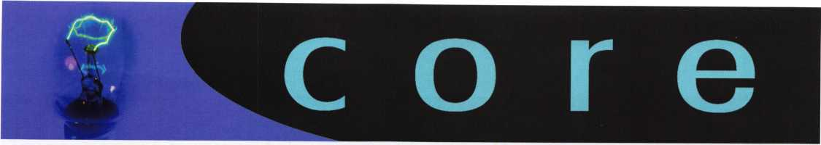

HICKORY HARDWARE INTRODUCES FIVE NEW STYLES OF STORM DOOR HARDWARE

Solid brass line is the first in the industry to match entry door hardware

Hickory Hardware's Wright Products today introduces the Accents line of finely crafted, solid brass storm door hardware in the Cumberland, Villa, Georgian, Serenade and Mortise styles. These storm door hard­ware products are the first available to coordinate in style and finish with Wright's line of entry door hard­ware.

The Cumberland and Villa latches, made with solid brass forged construction, are designed to replace most standard push button hardware. With bright brass interior and exterior finishes, the need to match paint colors is eliminated. Both latches incorporate a "No Lock Out" feature that prevents the latch from accidentally locking the door. The hardware fits most wood or metal outswinging storm doors from 3/4" to 1 1/4" thick.

The Georgian and Serenade hardware include lever styles and finishes that coordinate with Wright Impressionso Serenade locksets. Made of solid forged brass, the products come with an integrated keyed deadlock and low-profile escutcheon plate. The hard­ware fits most outswinging wood or metal storm doors from 3/4" to 1 1/4" thick.

The Mortise style lock is the highest quality line of storm door hardware available. The products fit doors 1" to 1 1/2" thick and include a built-in deadbolt with rekeyable Schlage® keyway. Lever styles and finishes coordinate with Wright Impressions Serenade locksets to create a consistent look in a customer's home.

Available under the Wright Products brand name, the products will be on display at the National Hardware Show in Las Vegas, May 9-11, at the Hickory Hardware booth #31 840.

Things that Go Bump in the Night (or Day)

By Jim Hancock

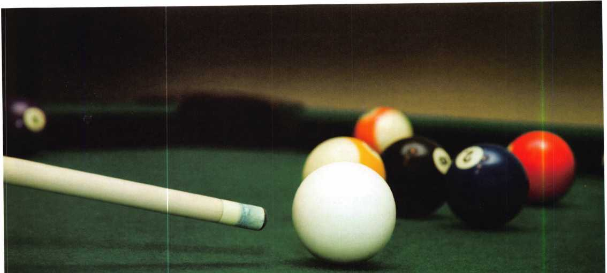

If you visualize the bottom pins as the cue ball and the  
pick gun as the cue stick, you will understand lock bumping.

Bump keys. Lock bumping. It’s the rage, it’s the hot topic for every talk show, news agency, homeowners association meeting and anyone it seems trying to strike fear in the hearts of the public regarding their security. It is the latest and greatest craze of hobbyists that spend their time try­ing to defeat locks. Due to this sudden surge in populari­ty, many in our profession are seeing an increase in sales of “High Security” locks and getting inundated with calls from concerned consumers wanting to know how to stop this action from compromising their homes and business­es. Sadly, many in our industry are taking advantage of the public by fanning the flames of their fear and using this as a means to peddle high end products that are being used on doors that are worth less than the locks. Lets take a look at the bump key and lock bumping, how it works, and how we as professionals can make locks more resistant to bumping without overselling a product.

HOW IT WORKS

Lock bumping has been used as means of bypass for

ID

Keynotes • April 2007

decades. It is certainly not new and as bypass methods go, it would not be one of the top choices used by most of us. Though it does work, and quite well on some types of lock, it lacks the professionalism exhibited when picking or raking or impressioning or even using a pick gun. To understand how it works, lets think for a moment about how a pick gun works. When using a pick gun, we insert a tension bar into the lock and apply light tension to the plug, creating a light bind on the pins, (pic #1) Then we insert the pick gun tip, and squeeze the trigger. (pic#2) If everything is done correctly and with some degree of luck, after a few pops of the gun, the lock will open. This is based on the same principal as used in croquet or bil­liards. If you visualize the bottom pins as the cue ball and the pick gun as the cue stick you will understand this readily. When you strike the cue ball with the stick, the ball moves. When it strikes a second ball, (the drivers in the lock) with the proper touch, what occurs? The cue ball stops where the contact is made and the second ball moves onward. When you pop the bottom pins, with the

proper tension on the lock, the bottom pins are hammered

against the drivers. The bottom pins stop in place

while the drivers are knocked upward. If your ten-  
sion is right, the drivers are driven above the  
shear line and this allows the lock to turn. A  
bump key, or bumping the lock works using the

same premise. With a properly cut bump key and -—

using the correct technique, the bottom pins are  
hammered against the drivers, creating separation and  
voila! A shear line.

BUMPING A LOCK

In order to bump a lock, the first thing needed is a proper-

ly cut bump key. This is the catalyst in a successful bump  
attempt. So what is a properly cut bump key? If you stop

and think mechanically for a moment what you are  
attempting, it should become clear what is need-  
ed. Since the shear line is created by separating  
the bottom pins and drivers at the top of the  
plug, you need a key that will not push any of  
the bottom pins above the plug surface with sim-  
ple insertion. So a proper bump key is one that con-

tains the deepest cuts available for the particular manufac-  
turer you are opening. And since we are attempting to  
shear 5 or 6 pin cylinders, this key should be comprised of  
the deepest cut all the way down the blade, (pic #3) But the  
real key (no pun intended) to the bump keys success is not  
just the cuts but the peaks between the roots of the  
cuts.(pic#4) It is the peaks that will drive the pin stacks.

With a properly cut bump key in hand, you now need something to “shock” or “rap” the key with. In order for this to work, you are going to have to immolate the actions of a pick gun. In other words, a rapid and sharp blow to the pins. You can not merely by hand accomplish this. What you use to strike this blow will depend on a couple of factors: (1) what you have available and (2) what you use to apply tension to the key. Because bumping, like picking et al, requires tension on the plug, you will need something to tension the key while striking it. Most of us that bump locks simply use our fingers. They are conven­ient (always have them with us, hopefully) and we get a better feel on the lock. Having said this, what I do not want to do is use a hammer as a striker. A finger when hit by a hammer hurts. A finger when hit while pinching the head of a key, hurts exponentially. What I generally use is the handle of a weighty screwdriver. (#5) This is generally plastic and provides the proper shock to the lock while providing little shock to me when I miss hit the key.

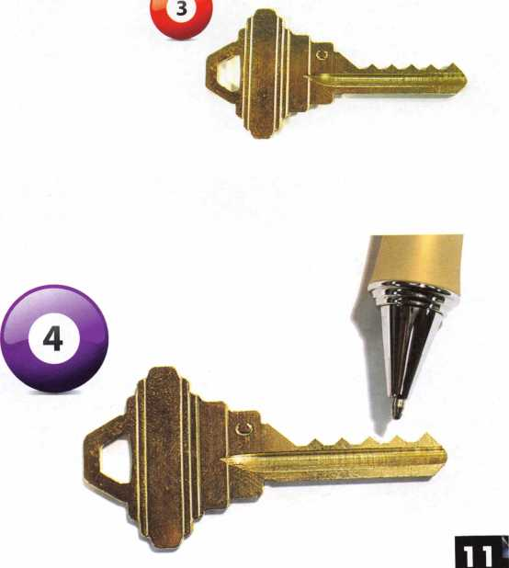

Keynotes • April 2007

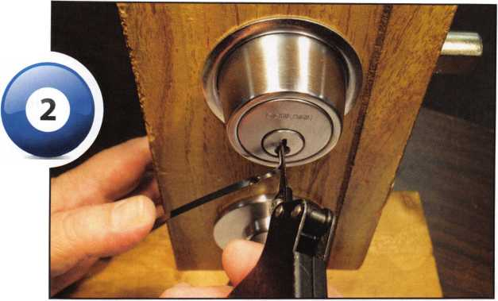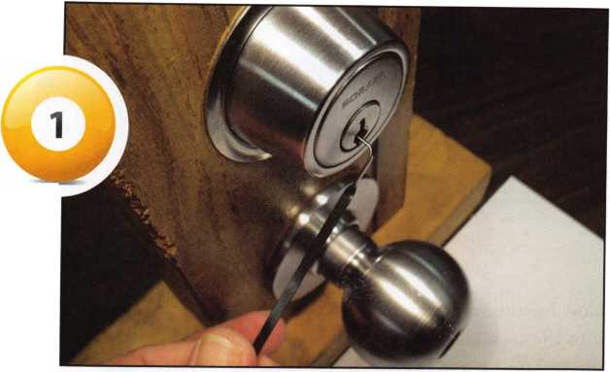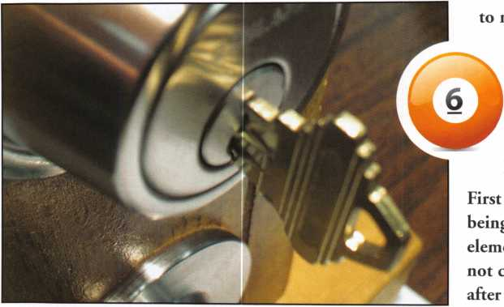

Now for the actual operation. First, insert your bump key into the lock all the way to the shoulder stop then back the key up by one space. (#6 & #7) Again, visualizing what is happening inside the lock, pin stack #1 is seated in cut #2, stack #2 is in seat#3, etc. The last stack in the lock, 5 or 6, is actually not seated in a cut at all but rather it resting on the tip angle of the key. With the key in this position, you now will put light turning pressure on the key. (#8) If using your fingers, the tension is light, do not go “white knuckle” on the tension. Just like pick­ing, raking etc., too much tension defeats the purpose.

With tension applied, use whatever striking device you  
choose and strike the end of the key. (#9) The strike  
should be sharp and firm but you are not trying to drive  
in the winning run in the bottom of the 9th. Sharp and  
firm, not heavy and hard. If the cylinder does not turn,  
while continuing to hold some tension, pull the key back  
out by one space and repeat the operation. You can gener-  
ally tell if you are shearing any pins when you try retract-  
ing the key after each strike because if you have pins  
sheared, pulling the key back becomes a struggle as the  
bottom pins can not move smoothly between the chamber  
in the plug and the now offset upper chamber. Struggling

•etract the key could also indicate too much tension  
on the key. You may do this 2 or 3 times before it  
opens, you may spend minutes on it and it may  
not open at all. Happy striking!

HOW CAN WE MINIMIZE LOCK BUMPINGS EFFECTIVENESS

let me say that lock bumping in my opinion is not  
**y** widely used as a method of entry by the criminal  
ent. Lets face it, most people in this line of work do  
:oncern themselves with salvaging a lock to be used  
entry is made. They will avoid the locked door com-

pletely if there is a perfectly good window or sliding patio  
door available. But thanks to the proliferation of videos  
being posted on the internet by hobbyists that bypass

locks for fun, common folks that just want to try it,

news media that sensationalize it as the wave of  
the criminal future, and of course word of mouth  
and innuendo regarding break-ins around town,  
we in this profession as stated earlier are being  
asked by the public to offer solutions to this men-

acing issue.

The easiest and quickest way to lesson the effect of lock  
bumping is to sell and install “High Security” locks such  
as Medeco M3, Mul-T-Lock, Assa, Primus. These locks  
resist bumping for several reasons, not the least of which

fi

**2**

Keynotes • April 2007

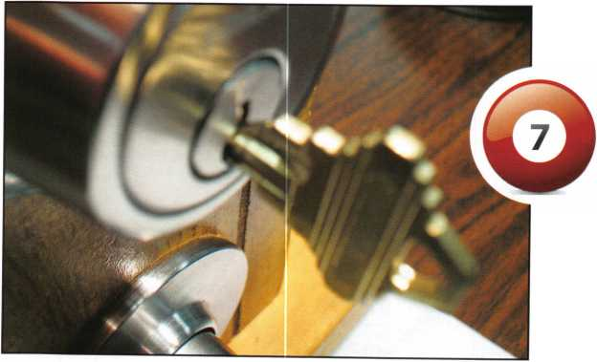

shape of the driver tend to cause the driver to get caught up at the shear line in the void of the pin surface.

These are just a few of the ways we can service our cus­tomers needs and alleviate their fears concerning bump keys. They are quick and simple measures and less costly for the customer than replacing existing locks with some­thing that may be overkill.

Let me close by saying again that I do not believe that lock bumping has replaced breaking a glass, opening a patio door, jacking a door, using unauthorized duplicates or any other of the myriad of means used by the criminal element to breach a house or business. It is simply the water cooler topic of the moment and we as an industry need to be able to deal with it fairly.

is that if they still retain patent rights, the blanks are not  
readily available. Also, anytime you are attempting a

bypass where you are not creating a simple shear  
line but also have to manipulate a secondary  
action or shear line, such as in Medeco where  
the pins not only have to raise to the proper  
height but must rotate to allow a side bar to shear,  
bumping just became almost impossible.

But what if the door that this lock is being utilized on is  
not substantial enough for such a heavy duty lock? Or  
more often perhaps is the scenario where the fear far out-  
weighs the likelihood of the occurrence. In other words,  
say an apartment dweller is concerned about bumping.  
The noise alone of bumping would almost certainly pro-  
hibit bumping as a “break-in” method of someone in an  
apartment setting with neighbors so close. But our

job is to protect the public and make them as  
secure as possible without taking advantage of  
them. So how do we accomplish this? Here are  
some suggestions:

Since the success of the bump key relies on that

hammer effect of the bottom pins bouncing the driv-  
er above the shear line while the bottom pins themselves  
remain below plug level, it could be reasonably assumed

that if we use the deepest pin avail-  
able in the brand of lock we are  
working with ( a 9 for Schlage, 0 for  
Sargent, etc) that when a bump is  
attempted, the longer bottom pin  
will perhaps jump enough to cross  
plug level and block the shear line,  
thereby thwarting the bump attempt.

Following the same logic as above for

why bumping works, it can also be assumed that using a  
stiffer spring combined with a longer than normal driver  
would be effective. Because of the longer travel required  
for the longer driver and the stiffer resistance of the  
spring, the hammer effect does not  
work as well.

Spool and mushroom type drivers will also prohibit bumping from being as successful for the same reasons they confound normal picking and raking. The combina­tion of tension applied to the cylinder and the abnormal

(spool pin)

Keynotes • April 2007

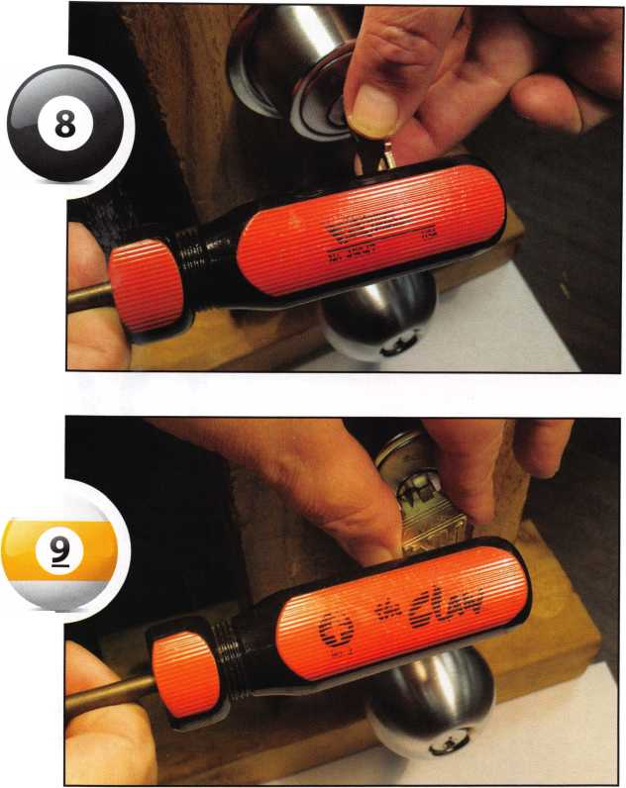

Welcome to our new monthly feature! Each month we will highlight a current ALOA mem­ber & their lockshop with a short bio and in-depth questions. To be considered or to recom­mend a fellow ALOA member please read the information provided at the end of this article.

Ijruy Gabai and S.O.S. Locksmith Corp. has been provid­ing locksmith and 24 hour emergency locksmith services in New York for over 30 years. They are also avid supporters of the Associated Locksmiths of America.

S.O.S. Locksmith Corp.

197 Seventh Ave.

New York, NY 10011

212-242-1708

[www.sosiocksmith.com](http://www.sosiocksmith.com)

1. Tell us about your background in security and your experience in locksmithing.

Guy: My family started SOS Locksmith in 1974. As I kid I would come by and I loved watching all the action in the shop. Approximately 12 years ago I started coming more often and have been here since.

1. What is your favorite place to visit in New York?

Guy: The West Village in my favorite area in NYC.

1. Why?

Guy: There is always something going on, day or night. There is a great deal of diversity in people, restaurant and shops. In one block you can find ethnic food from 10 different countries. And it is also a residential area that has beautiful architecture and brownstones.

1. How did you get involved the business?

Guy: I got involved when I was in college during summer break. My mom was running the company alone ( my father had just passed away). And I wanted to “help the family out.”

I started to go on service call with technicians and I found it very exciting.

“We sell by having a good reputation as a company that has been around for 33 years. Most of our business comes through word of mouth and referrals.”

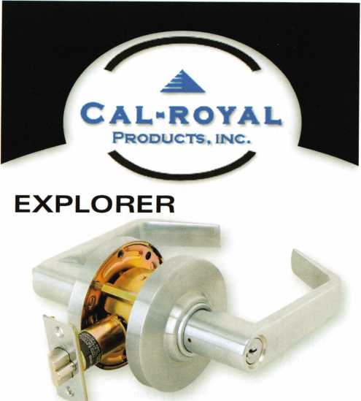

Non Clutch Mechanism, "XP" Series

Fits All Major Manufacturers Thru Bolt Locations

COMMANDER

Clutch Mechanism, "Com" Series  
Large 1C Format

9800 EXIT DEVICES

1

7

Grade 1 Heavy Duty Exit Devices  
Available in all Architectural Finishes



**Cal-Royal Products. Inc.**

**6605 Flotilla Street. City of Commerce. CA 90040 U.S.A.**

**Tel: (323) 808-6601 • (818) 888-6601 • (800) 876-9258  
Fax: (323) 888-6699 • (818) 888-6699 • (800) 222-3316  
E-mail: [sales@cal-royal.com](mailto:sales@cal-royal.com) • Website: [www.cal-royal.com](http://www.cal-royal.com)**

Keynotes • April 2007

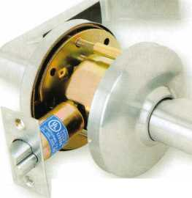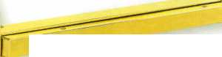

“My family started SOS Locksmith in 1974. As I kid I would come by and I loved watching all the action in the shop.”

1. Tell us the changes you have seen in security technology recently.

Guy: There have been many changes especially in the area of high security locks and cylinders. Restricted keys have become way more popular, also electronic locking devices have developed quality hardware and software.

1. Do you find that other locksmith in the New York area work together on referrals and work flow?

Guy: Unfortunately, other locksmiths in NYC do not work as a team as I wish they would. There are many fly by night fake locksmith that rip people off and give the market a bad name.

1. Can you remember your first big security job? What can you tell us about it?

Guy: My personal favorite is a Master Key System and CCTV System upgrade that we did in a hotel near our shop.

1. What has been your most exciting project to date?

Guy: One of our company’s most exciting job was a com­plete security upgrade for a Court House of the Mayor’s office in East Orange New Jersey. The job included a full CCTV installation, lock and panic hardware, audio and a video intercom system.

1. What advice can you give to an aspiring security professional?

Guy: To be very knowledgeable about your products and different product lines and to follow-up on what is in the market place. And off course, good service and reliability. That is the way you can develop a reputations like we have of a company that the public knows they can trust and rely on. It can be a very competitive business and the more you know about your product the greater advantage you have.

1. How do you stay informed about new products and security techniques?

Guy: I read magazines, go to trade show and seminars and keep in close contact with our distributors and manu­facturers.

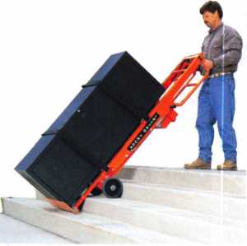

***Lectr&Truck***

| STAIR CLIMBINGS SYSTEM

Visit us online at:

[www.lectrotruck.com](http://www.lectrotruck.com)

...or call us today at:

800-619-0625

The Lectro-Truck will make it easier for you to break back a load, climb and descend steps, and even load onto your truck or trailer!

Save on damage costs.

Save on injury costs.

Save on labor costs.

The bottom line: You save money!!

The Lectro-Truck makes this all possible - all while having a 1500 # capacity!! Call us today to find out what you have been missing.

**6**

Keynotes • April 2007

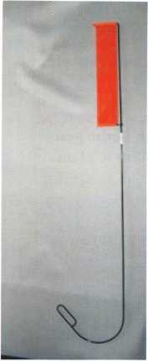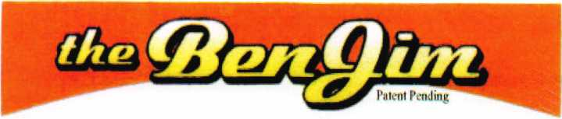

Emergency Door Opening Tools

AS SEEN AT THE 2006 A.L.O.A CONVENTION

All commercial buildings have two things in common:

* Fire code requires that all commercial locks open by a single action.
* The American Disability Act requires free access through doorways,  
  which leaves a gap between the door and the floor.

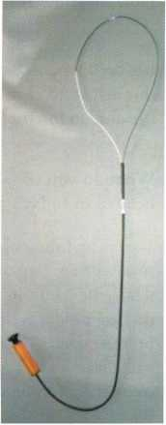

Knoblock Tool

Leverlock Tool

WITH THIS IN MIND WE HAVE DEVELOPED THE TOOLS REQUIRED TO EFFECTIVELY  
OPEN DOORS QUICKLY AND WITHOUT DAMAGE

Designed for interior commercial doors

For knoblocks, the tool is slid under the door with no cords to pull or get tangled.

For leverlocks, a similar tool is used by applying the same method of sliding the tool under the door and pull until the lever retracts.

Both tools are designed to work with very little effort, excessive force is not needed.

Visit our web site at [WWW.THEBEN-JIM.COM](http://WWW.THEBEN-JIM.COM) for more details.

THE BEN-JIM KNOBLOCK TOOL $ 99.00

THE BEN-JIM LEVERLOCK TOOL $ 79.00

SET (one each) $169.00

PLUS SHIPPING & HANDLING

**TO PLACE AN ORDER CALL 1-586-778-1911 OR VISIT US AT [WWW.THEBEN-JIM.COM](http://WWW.THEBEN-JIM.COM)**

MADE IN THE U.S.A BY THE BEN-JIM CORPORATION.

24711 Harper Ave. * St. Clair Shores * MI * 48080 * (Fax) 586-778-0530

1. How do you sell security to the public?

Guy We sell by having a good reputation as a company that has been around for 33 years. Most of our business comes through word of mouth and referrals. We also have a web­site and do internet advertising and through store sales.

1. What do you see as the future of security? Where are we headed in today’s age of technology.

Guy The future of security is confusing. Many manufac­turers are coming out with too many electronic products - which are confusing customers. Also many companies are making products that are very similar - and once a new product comes out, it seem to change too quickly. We will always have a mechanical lock and key, electronic technology can only go do far - so I feel it will have to slow down.

1. Name one thing in your lockshop that says the most about you.

Guy: Variety: many different types of people, situations and jobs - each day brings a new challenge.

1. How has life changed for you as a locksmith in the past few years? Do you feel personal responsibility to secure the US?

Guy:

1. In many way life has not changed for our company we are and have always been busy.
2. In terms of my personal feeling of responsibility to keep our country safe - I do feel our company is in a position to help. However, my frustration rises when I see large jobs get low bids, with inferior equipment and insufficient secu­rity coverage which leaves the public far more vulnerable.

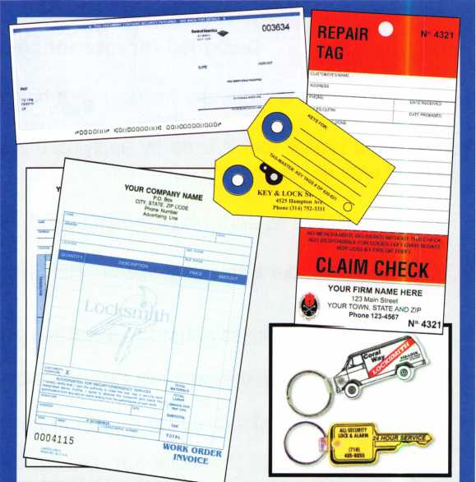

|  |  |  |
| --- | --- | --- |
| Professional Business Products | | |
| Invoices | Tags | Call for a free |
| Checks | Key Fobs | brochure and samples |
| Business | Magnets | 1-800-355-6322 |
| Cards | Labels | [www.pbp2000.com](http://www.pbp2000.com) |

**8**

Keynotes • April 2007

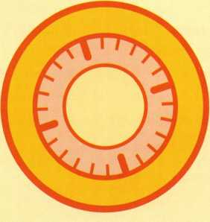

**BRIGHTEN** YOUR  
FUTURE. **HIGHLIGHT**YOUR SUCCESS!

**SAFE & VAULT**

'isSlI

**TECHNICIANS ASSOCIATION CONVENTION & TRADE SHOW**

■■HI

Highlight your path to the future with the latest technolo­gy the industry has to offer to safe technicians at SAFETECH 2008. Exposure to today’s top safe distributors and manufac­turers is absolutely crucial to making good purchasing and sales decisions. Additionally, time is of the essence when it comes to education. New developments spring up each year, making top-notch safe

classes a necessity in our ever-changing environment. SAFETECH classes cover subjects related to the installa­tion, maintenance and opera­tion of sales and vaults at lev­els from novice to expert. The only chance to get world-class education and meet with the industry’s top distributors and manufacturers is at the 2008 Safe & Vault Technicians Convention & Trade Show.

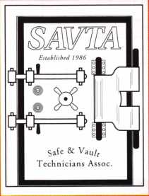

**SAFETECH 2008**

March 31 -April 5, 2008  
Bahia Resort Hotel  
San Diego, California

[www.savta.org](http://www.savta.org) • 214.819.9771

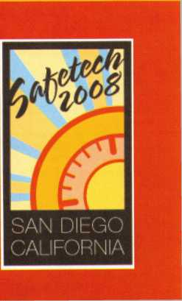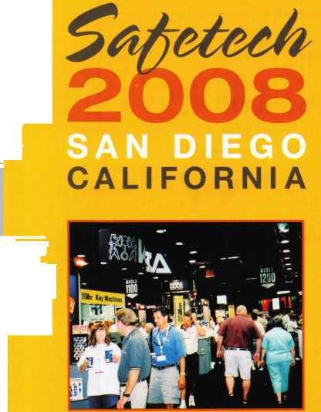

1. Name a few things that locksmith business owners should do to help their businesses prosper and grow.

Guy:

1. Be available to personally speak and meet with clients
2. Take care of your employees
3. Use good materials on jobs
4. Give good service and don’t take advantage of the public.
5. Stand behind the products that you sell.

*You must be a current member of The Associated Locksmiths of America in order to be recommended for our Member Spotlight feature. If you would like to be recom­mended or would like to recommend someone else please email our Keynotes Editor, Betty Southerland at [betty@aloa.org](mailto:betty@aloa.org)

\

You need it When?

**How about now!? :-)**

ClearStai: ft

Se«orkV

Another Special  
Value-added Benefit to your

ALOA Membership! Click here

f * ^

[www.clearstar.com](http://www.clearstar.com) / ALOA

V)

Keynotes • April 2007

9

Real Security Is When Do-Overs  
Take Place Only On Your Personal Time

When you install Schlage® locks, you know you've done the job right. After all, our products are among the most durable and dependable on the market today. They're also easy to install, repair and maintain, so they generate fewer callbacks. Which means you're free to concentrate on other things. Like learning how to pick up the 7-10 split.

33HE3?

Real Security Sets You Free

[www.schlage.com](http://www.schlage.com)

£

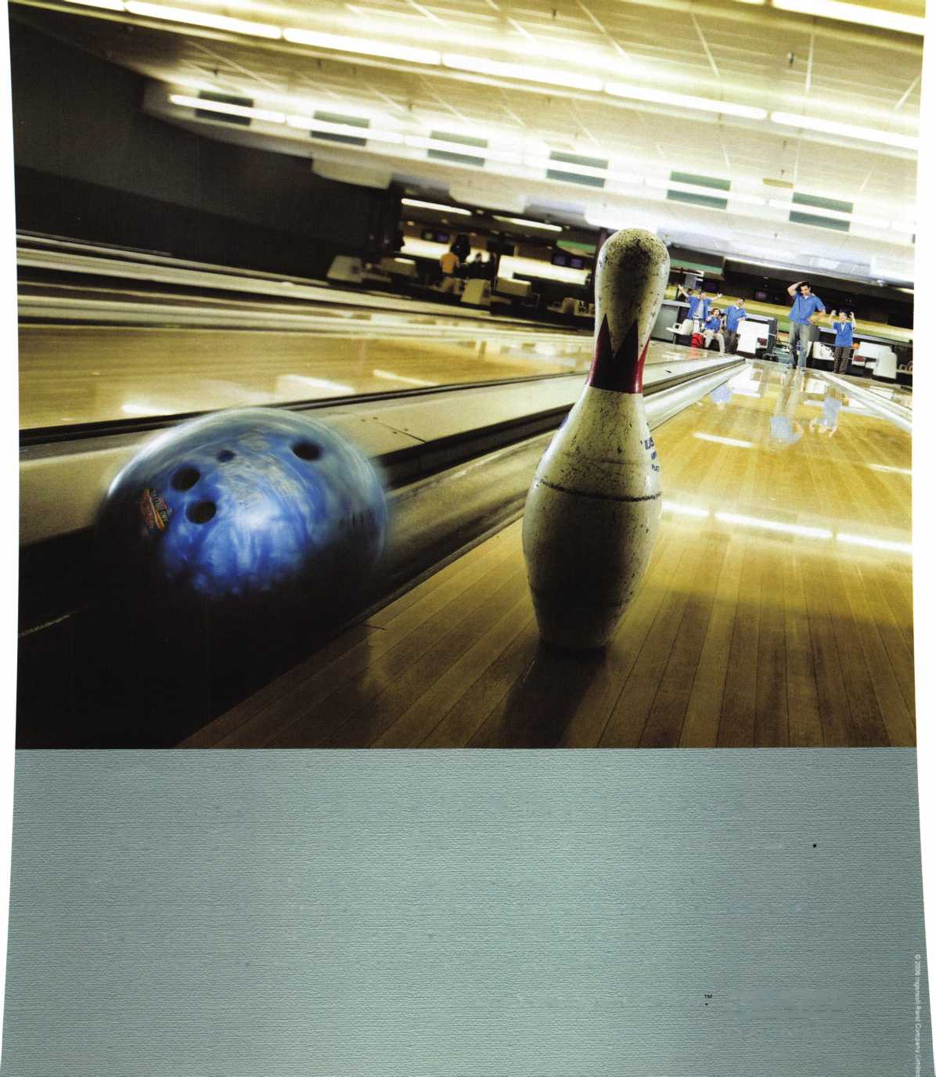

It’s in the Fingers

(Follow-up article to Something Old Something New... March 2007 Keynotes)

By Greg Perry, CML, CPS

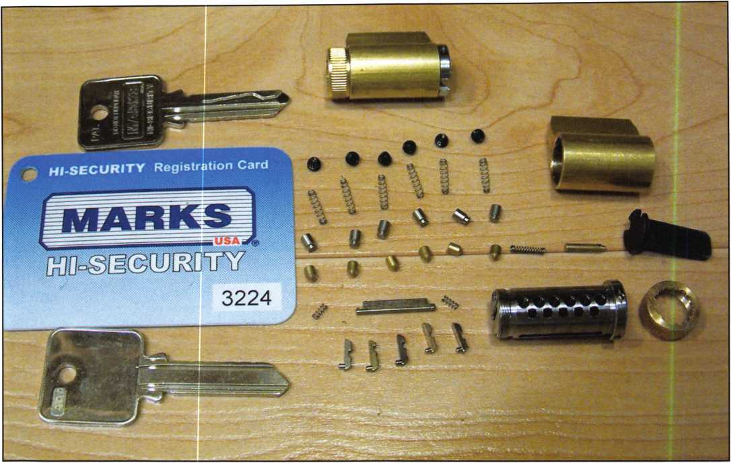

Photo 1, The non-UL cylinder is disassembled. Above it is the UL listed version.  
Also shown in the picture is the signature card for additional keys.

Last month, I teased a new product line from Marks USA®, their Hl-Security cylinders. Reasonably priced, starting at $46.00 to $74.00 list for the non-UL listed version, they are probably the latest entry into the high-security market and just in time for all the hoopla about bump keys. Bump keys have been hyped in the news lately. If you’re not familiar with what a bump key is see the article in this month’s Keynotes, the ALOA web site at ALOA.org or “Google” it for more information. Marks USA® High Security cylinders are pick, drill, and bump-key-resistant.

They offer patented key control and keys can be cut on a standard key machine. It’s time to look inside this cylinder and look at what makes it Hi-Security.

The cylinders are available in five basic designs and two levels of security. First, is the standard mortise cylinder available in lengths from 1 1/8” to 1 3/4” long. Next, is a product I’ve wondered why others don’t produce, a combi­nation mortise/rim cylinder. This cylinder is threaded on the outside and has the traditional two screw holes in the housing. The plug has two screw holes for a mortise cam or a plate with a slot for a rim cylinder tailpiece. It’s avail-

Keynotes • April 2007

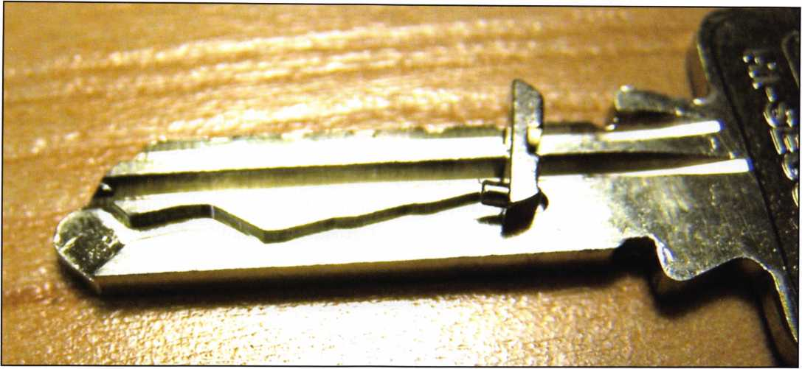

Photo 2, A close up of the side milling on the key with a finger pin laying on top.

able in both a 1” and 1 1/8” version. Key- in-knob (or lever) cylinders to fit Marks USA® levers and knobs and are the same physical size as Schlage® cylinders are available and will soon be available with a lazy cam tailpiece for use in deadbolts. If you can’t wait until the lazy-cam tail­pieces are available then use the ones from Schlage® or Ilco® cylinders. Both worked on the Marks USA® key-in-knob cylinder. Need interchangeable core? Marks USA® provides a cylinder in the Schlage® large format or the Best® small format interchangeable core (SFIC) size. The two levels of security are UL437 list­ed and Non-UL. The SFIC size is only available in the Non-UL security level.

The first thing you’ll notice is that the key has an irregular milling on the left side of the key. This is for the finger pins that line up for the side bar. The usual method

IN-STOCK...MORE SAFES

*FREE Freight Program*

*(30 States)*

AMSEC FireKhg

Gadall **hayman**

MEIUNK **yiCTOK**

TURfl IO

**WHOLESALE SERVICE**

800-848-9790

Keynotes • April 2007

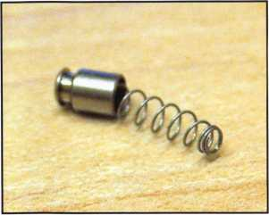

Photo 3, The hardened steel top pin  
with the spring partially inside.

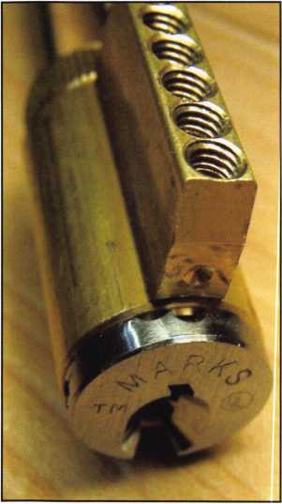

Photo 4, The threaded chamber holes  
can be seen at the top of the bible.

of keying these cylinders is through the top of the bible or cylinder. They use standard-bottom and master-wafer pins from your everyday pin kit or SFIC pin kit. The top pins are special; they are hardened and have a hole in the top of them for the spring to enter. Why the hole? The cylinders are capped with setscrews; this takes up some of the normal room in the bible or cylinder housing. The springs need room to compress as keys are inserted; the holes in the top of the pins allow this room. The hardened top pins also deter drilling, a requirement for the UL 437 listing. Using them in both pro­vides a higher level of security for the non-UL cylinders.

Looking inside the cylinder at the plug reveals what makes these cylinders tick. The plug has an extra set of holes next to the pin chambers for five fin­ger pins. These finger pins are available in four sizes or choices; #1 pins are silver, #2 are copper, #3 are black and #4 are gold. Normally, you should never need these pins since the cylinders come to you assembled with the appropriate finger-pin configuration. Keying is performed through the top of the bible. The only time you might need these parts are if you lose them after taking the cylinder further apart than necessary. The other part to this system is the hardened sidebar. It has two small springs pushing it out of the plug into a slot in the housing. When a key with the proper side milling is inserted, the finger pins are lifted to the appropriate location and the side bar can enter into the slots on the finger pins, very similar to automotive sidebar or Medeco® locks.

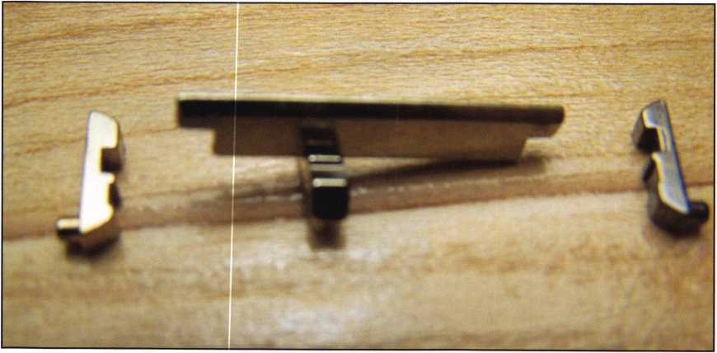

Photo 5, The side bar has been removed and is sitting on top of a finger pin.  
Two other finger pins are at each end of the side bar.

Keynotes • April 2007

120 Glasgow Avenue, Inglewood, CA 90301 U.S.A.

T: 310-645-0023 1-800-826-7493 F: 310-641-1586 HI it ffwL

E-mail: [info@doorkinq.com](mailto:info@doorkinq.com) [www.doorking.com](http://www.doorking.com) /” — *

**DOORKING**

1838 Multi-door Controller

ting and Manufacturing a full line of product since 1948

**How Can a Simple Little Box**

**Deliver So Much?**

The DKS 1838 is a two-door controller that is much more than that.

For starters, it easily expands to control up to  
16 doors. Reporting capabilities are included,  
which makes the DKS 1838 ideal for small  
businesses, office buildings, factories,  
industrial sites, apartment complexes,  
condominiums, gated communities...

And more:

* elevator option to control 4 elevators  
  serving up to 64 floors each, with  
  floor access restrictions built-in
* anti-pass back for complete control  
  into, and out of, secured areas
* live transactions - view activity  
  in real time on your computer
* interfaces with card readers,

RF controls, keypads, etc.

* access control for up to  
  3000 users

And that’s not all.

Call today and let us show you how DKS can simplify your life.

DoorKing telephone entry systems have always been our preferred systems, because they can fit any application we Ve ever run across - small and simple to large and complex.11

Rich Gonzales

Vice President

Mid Atlantic Entry Systems LLC Abingdon MD

Card Readers Keypads RF Controls

ACCESS CONTROL SOLUTIONS

Member: AFA, DASMA, IDA, NOMMA, SIA, SSA

for over fifty years

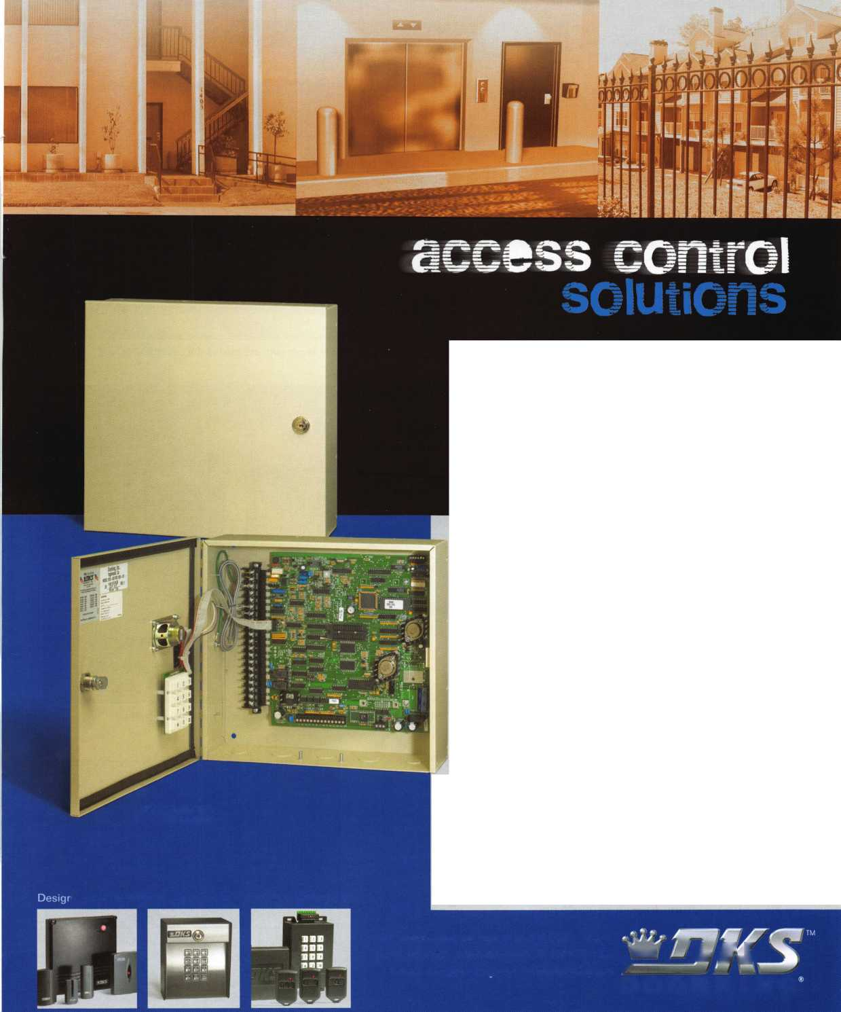

What’s the difference  
between the UL437 and non-  
UL listed cylinders? Simply,  
the amount of drill resist-  
ance, the non-UL cylinders  
have two hardened roll pins,  
each protecting a shear line.

The UL listed cylinders have  
four additional hardened pins  
inserted into the plug to bet-  
ter prevent drilling. Both use  
the hardened top pins. The  
extra protection costs only  
$14.00 more for the mortise,  
rim, and key-in-knob cylin-  
ders and only $12.00 more  
for the Schlage® large format  
interchangeable core.

Marks USA® Hl-Security  
cylinders in the non-UL fill a  
price point currently missing  
in the pick and bump-key-  
resistant market. Often, the  
residential homeowner or the  
small business owner might  
want better quality but in  
many areas the number of  
doors and the cost between

locks and cylinders is so great they choose to “live” with what they have installed. These cylinders will fill the gap between the higher-end and standard cylinders. Keying with a standard pin kit and cutting the keys on standard key machines will keep the retail price of keying and cut keys in the range of the more common locks. They will be a great addition to your product line.

Photo 8, The UL listed plug has the addition of four more

hardened pins to resist drilling. Looking back at photo 6  
you can see the two pins.

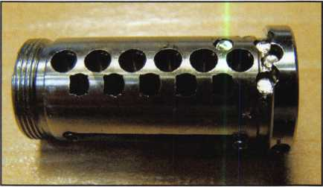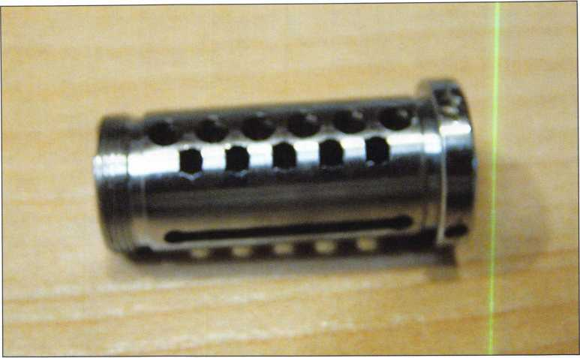

Photo 6, The second set of holes for the finger pins are next to the pin chamber holes.

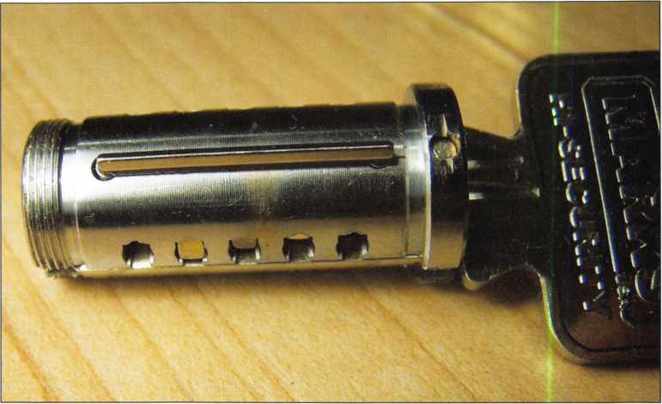

Photo 7, The bottom of the plug with the finger pins at the various depths.



Keynotes • April 2007

**\*s>//**

***/&Aloa*** <p

. Don't miss the ALOA Opei?.-'Golf Tournament

2007!

Held during the ALOA Convention and

• •

Security Expo, this is a great -event*

for friends, food an#d.so#m^dncrazj^^^

ing networking **opport0mtiesjf^^^^^|**

Register early to.eneure^pk^c**V **£•; *.{**

grouping preferences. **You#ft^i’^C^#** r * •, t - -1-VAvVv;. want to move tast betore **wfev?t**f • .**

**\* :'i ' l..**

reach the 144-player cut off,**'V*. ;*. .**

**\* * ’ •** As always, proceeds from **• •**

the tournament will benefit

the ALOA Scholarship

**'7! !**

Foundation. Use the **convjjly*#■!**

tion registration form, found **^ *s**

***iMTnM \*\****

online and in the ALOA **IOf/m • \*** Convention and Security Expo brochure to save yt>ur Ipot **today] \***

**This year, the popular ALOA Golf Tournament** •/' **Irl**

**will be held at the area's finest daily-fee golf Jp** m **jKjjfr, r \** 1

**course, the** 18**-hole Arnold Palmer-designed**

**championship golf course at Birkdale in \**

**Huntersville, NC. Voted the "Best New Golf**

**Course in North Carolina " and one of the "Top Five Public Courses in the State," this excep tional course features facilities that range well beyond the** 7**,**013**-yard layout of golf holes.**

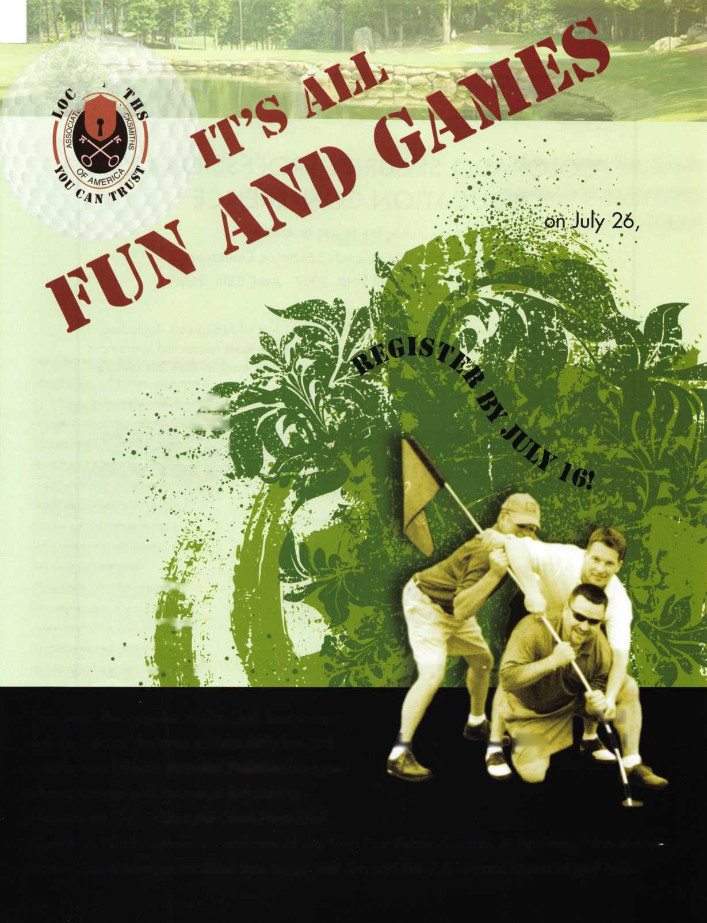

COLORADO SECURITY PROFESSIONALS  
EDUCATION CONFERENCE

Announcing the fourth Bi-Annual  
Colorado Security Professionals Education Conference.

Mark your calendars, April 26th, 2007 - April 28th, 20071!

We have put together some great classes as well as lots of fun events. Including a  
free dinner buffet and evening trade show. Some of the most respected instructors  
in the industry will be teaching our classes. You don't want to miss this unique

opportunity.

Learn all about. Master Key Methods & Formats, Electronic Access Control, Basic  
Locksmithing, Life Safety Codes and ADA Codes, Keyless Mechanical Lock  
Servicing, & Basic Electricity & Electronics. There will also be an ALOA PRP sitting

Classes will be held at:

Radisson Stapleton Plaza Hotel  
3333 Quebec Street  
Denver, Colorado 80207

(For Hotel Reservations call the hotel at 303.321.3500)

For online Conference registration or to download a registration form go to  
[www.securityeducationweekend.org](http://www.securityeducationweekend.org) or call: 303.688.4104 Or go to the website:  
[www.radisson.com/SecurityEducationWeekend](http://www.radisson.com/SecurityEducationWeekend)

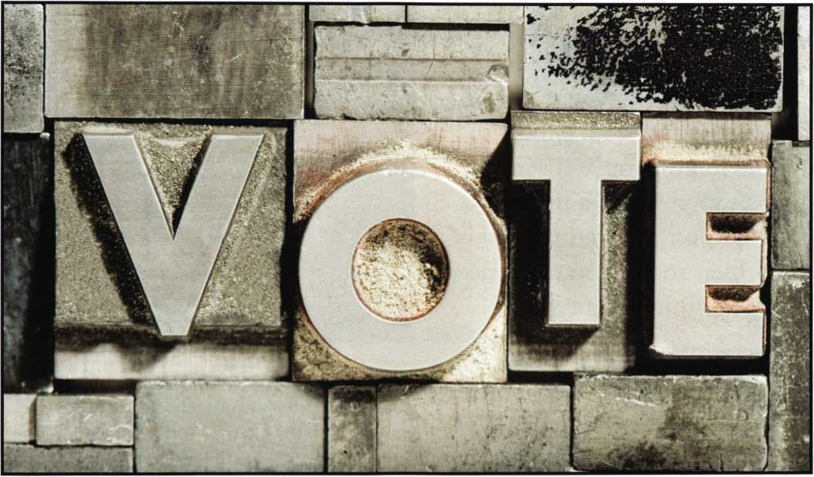

BE SURE TO

IN OUR UPCOMING  
ALOA BOARD  
NOMINATIONS!

Ballots will appear in next month’s Keynotes.

The Art of Persuasion:

Get the Edge You Need to Reach Your Goals

By Paul Endress

Regardless of your industry or pro­fession, chances are you regularly have to persuade others to adopt your ideas. Whether you’re persuad­ing a client to buy your product, your boss to give you a raise, your co-worker to give you a piece of that key project, or even your kids to clean their room, you often need others to see things your way.

And while research shows that most people believe they cant be sold, the fact is that those same people can indeed be persuaded if they don’t recognize that a “sales” technique is being used. That’s why smart pro­fessionals today are using the art of persuasion, rather than sales, to get others to do what they want.

Realize that persuasion does not involve tricks, gim­micks, lying, or anything unethical. When you use persuasion techniques you are merely employing sim­ple psychology concepts to make your message more credible and believable. And for persuasion to truly work, whatever message you’re conveying must be based in truth and delivered with the right intentions. After all, you’re persuading someone to your point of view, not conning someone to do or think something questionable.

With that said, following are the persuasion principles that will give you an edge so others adopt your ideas with ease.

1. Aim at a narrow target. When attempting to get someone to adopt their ideas, many people do a data dump on their listener. They give every possible fact,



figure, and feature in hopes that some of the informa­tion will stick and persuade the other party. However, if you want to be effective at persuasion, then you need to keep your focus during the conversation as narrow as possible. So rather than talk about every­thing possible that might persuade the other person, find out what’s important to your listener and then persuade on those points only. The best way to uncov­er what’s important to the other person is to ask. That’s right...simply ask, “What’s important to you about... [insert whatever topic you’re addressing].” Then listen to what your listener says and speak only to those points.

If asking such a direct question doesn’t seem appropri­ate for your situation, you can couch your question within a statement, such as, “I was talking with some­one the other day about [insert your topic], and they told me thatwas the most important thing to them about [insert your topic]. That wouldn’t be important to you too, would it?” So your statement could sound like: “I was talking with someone the other day about buying a car, and they told me that

Keynotes • April 2007

**WE ARE LISTENING TO YOUR NEEDS!**

**GET READY. CHANGE IS  
AROUND THE CORNER!**

Take a LOOK at some of the new things  
ALOA has planned for YOU in 2007.

ALOA is excited about the new changes in-store  
for everyone in 2007. For this membership cam-  
paign we have listened to the membership and  
are rapidly making changes to suit your needs.

• Don’t miss out as we roll out our new & improved Keynotes  
magazine introducing such interactive features as a  
Q&A section exclusively for members.

• More user-friendly ALOA website.

• More training & education opportunities.

• Better and broader networking possibilities.

• ALOA store with more books plus NEW products that help YOUR bottom line.

ALOA offers you the strength of over 8,000 leading  
firms & individuals. ALOA is YOUR voice in the  
industry. ALOA represents the collective interests  
of the association to the press, government, and the

public. ALOA is able to open many doors needed for

success in our ever-changing industry.

**CONTACT:**

**Associated Locksmiths of America 3500 Easy Street**

**4-819-9736**

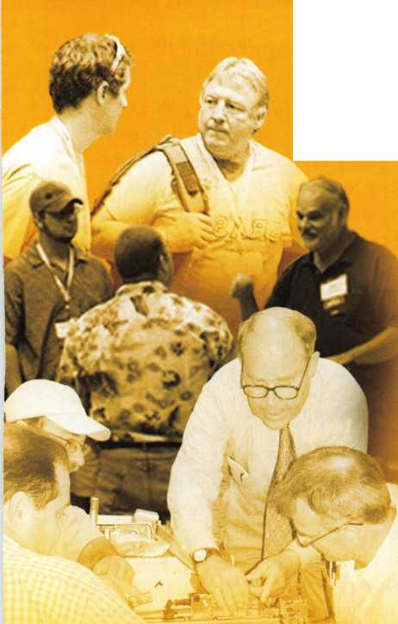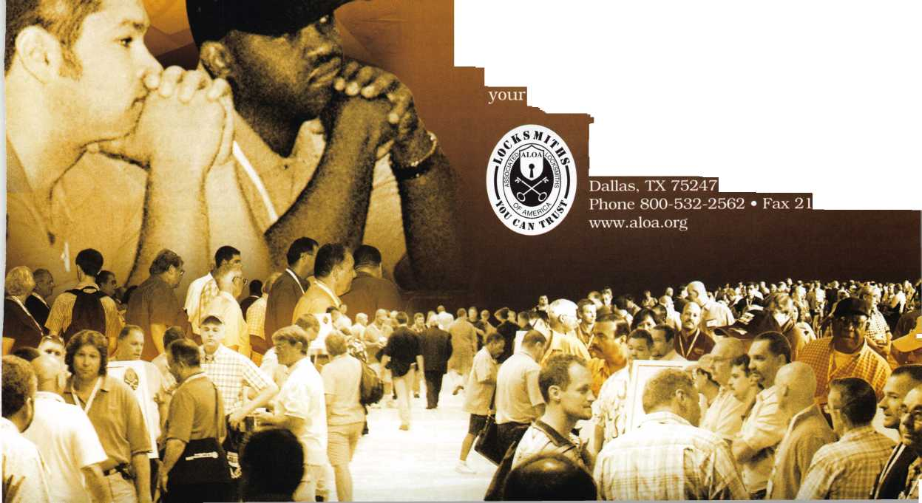

gas mileage was the most important thing they con­sidered when purchasing a vehicle. That wouldn’t be important to you too, would it?” Allow the person to answer and give you the information you need. Then you can gauge how to direct your conversation based on their response.

1. Use stories to convey your message. Stories are an extremely effective way to persuade. However, many people are too obvious with their stories, and as a result they come across as giving a sales spiel. The best way to use stories as a persuasion tool is to simply tell your listener about something that is similar to your concept (an analogy). For example, suppose you want to convey the idea that your product will give the per­son peace of mind. First, determine what that idea is like...what is similar to having peace of mind? You may decide that “relaxation” is similar to the concept of peace of mind. If so, what conjures up images of relaxation to you? To this you might reply that a day at the beach equates to relaxation. If so, then tell a story about a day at the beach.

Here’s another example: Let’s say you’re trying to motivate you staff to try something new and you want to convey the idea of being open to discover new ideas. What is that idea like? What is similar to dis­covering new ideas? For many, it’s similar to being sur­prised. So then, what else elicits a surprise? How about opening a present? Tell a story about that. The point is to pinpoint what you want to convey, decide what that idea is like, determine what else is like that main idea, and then tell a story about the similar con­cept, idea, or thing. This indirect approach works.

1. Use a second or third party quote. Sometimes you may have to tell people bad news in order to get them to see things your way. If you don’t want to be the bearer of bad news, you could use a second or third party quote to tell the news for you. For example, you could tell a client, “I was talking with Joe Smith the other day and he said that ABC Company has trouble making deliveries on time.” Another example would be to say “My father used to always tell me

”, and then tell them what you want to tell them. Who could argue with your father? The only caveat is that you cannot use this technique to

say something that is not true. The goal is to deliver truthful news or make a point in a way that doesnt reflect poorly on you or make you appear as though you’re selling.

1. Use pacing and leading to prove your point.

Pacing and leading involves the idea that if the brain can verify two things as true, it will accept the third fact as being true too. So if you tell someone, “My name is Mary Jones and I’m with Acme Corporation,” the listener’s mind can quickly verify those two facts as true. Then whatever you say next, such as, “We have the lowest prices on your office supply needs,” rings true to the listener as well. Again, you cannot use this technique to say something false. Whatever your third piece of information is, it must be a reasonable fact.

A Slight Edge Yields Huge Rewards

None of these persuasion techniques are magic or “smoke and mirrors.” They are designed to give you a slight edge in your dealings with others. And if you think a slight edge is meaningless, think again. After all, in the Olympics, the difference between those who win the gold and those who win the silver is often just a few hundredths of a second or a fraction of a point. A slight edge goes a long way. So arm yourself with these persuasion tools and make them a part of your everyday conversations with others. When you do, you’ll find that others are more apt to adopt your ideas, resulting in more winning solutions for every­one involved. I

About the Author:

Paul Endress is a nationally recognized presenter and expert in the appli­cation of psychology to the business world. His expertise in the areas of communication, hiring and retention is the result of more than twenty years of entrepreneurial experience and over five years of research. Paul is President of Maximum Advantage International, a firm specializing in hiring and sales solutions, and is a certified Practitioner of NLP as well as hypnotherapy. For more information on his speaking and consulting, please contact: [www.maximumadvantage.com](http://www.maximumadvantage.com)

**32**

Keynotes • April 2007

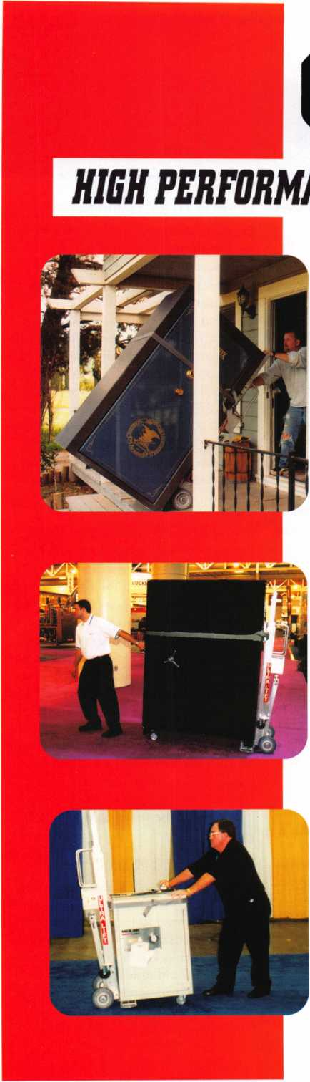

***OPERATOR SAFETY***

Injuries can be virtually eliminated. Ultra Lift does the lift­ing so that operator effort required to complete a move is minimized. Heavy loads are broken back with ease. The operator stays in control by using a combination of motor power, balance and leverage in every phase of a move.

***REDUCE LABOR COSTS***

Fewer people are required for any move with Ultra Lift. Manpower can be scheduled more productively. Labor savings often pay for the Ultra Lift in one month.

***ELIMINATE DAMAGE***

Loads are broken back, set down and moved under power with maximum leverage and operator control. Gentle handling eliminates bumps, bounces and damage to the load and premises.

***INCREASE PROFITS***

Increased operator safety, reduced labor cost and elimina­tion of damage to the load and premises all contribute to significant increases in profits.

FOR LITERATURE, VIDEO OR ON-SITE DEMONSTRATION, WRITE OR CALL:

ULTRA LIFT CORPORATION

475 STOCKTON AVENUE, UNIT E SAN JOSE, CA 95126 800-346-5057 408-287-9400 FAX 408-297-1199 E-mail: [info@uitralift.com](mailto:info@uitralift.com) [www.ultralift.com](http://www.ultralift.com)

ULTRA LIFT supplies the power — so you don't have to. One person can safely and easily handle loads that usually require 2 or 3 people, even up or down stairs. Two people can handle most safes to 1500 pounds. If safety is your concern, ULTRA LIFT is the best move you'll ever make!

**U.S. PATENT 4.570.953**

**Classifieds**

EMPLOYMENT

EMPLOYMENT OPPORTUNITY

Welcome to fabulous Las Vegas! The City of Excitement and Opportunity. Liberty Lock & Safe is looking for experienced and entry-level locksmiths. Our team of 55 dedi­cated Security Professionals provides the services of CCTV, Access Control,

Hardware Installation and residential com­mercial and safe services in this great city. We are looking for motivated individuals for our Road Service Department and our Front Counter Department. Top pay for peak performers. If you have the skills, we have the work. Benefits include paid vaca­tions, generous commission plan, medical and dental insurance. We provide the com­pany van, you supply your tools. We have regular manufacturer's in-house training seminars and an excellent support staff to help you be all you can be. If you are an apprentice, our company can hone your skills and turn you into a superstar in mini­mal time! All we require from you is ambi­tion and drive. Applicants must possess a good driving record, be people oriented, have a neat appearance and pass a back­ground check. Call today 702-871-KEYS, ext 2224 for more information on this exciting opportunity. Email your resume to [james@libertylock.com](mailto:james@libertylock.com) or fax to 702-876- 5470.

WORK WITH US

My name is George Klein. I am a 3rd gen­eration locksmith and became owner of John Koons Locksmiths in 1979. The follow­ing employees and the year in which they started working with me at Koons Locksmiths:

Gino 1979, Beth 1979, Jim 1986, David 1986, Steve 1993, Kirk 1993, Don 1995, Lew 2002, Lew Jr. 2003, Mark 2003, Josh

1. Scott 2005, Mike 2005, Kevin
2. Jeff 2006, Alison 2006. If you are an experienced locksmith and want to join

us working inside one of our shops or work outside services, please call 1-800-282-8458 or fax a resume to 239- 939-5869. John Koons Locksmiths/Fort Myers, Florida.

EMPLOYMENT

San Diego Locksmith and Access Control Company has openings for Locksmiths and Access Control Techs! Grah Safe and Lock is a full service security company that does primarily commercial, industrial and gov­ernment work. Master Key Systems, Safe work and Access Control are areas that we keep full schedule. If you know of a hard­working, customer friendly technicians, who works now in, or would like to grow into this type of work, have them contact us. Positions to work alone, or as a trainee working with an experienced Locksmith or Safe Tech available. Paying $30K to $60K to start, depending on experience and abil­ity. Visit us online at

[www.grahsecurity.com](http://www.grahsecurity.com). Letter of introduc­tion and resume to [glen@grahsecurity.com](mailto:glen@grahsecurity.com) 939 University Ave San Diego, California 92065

RETIREMENT/COMPANY EXPANSION

Maziuk Wholesale Distributors, headquar­tered in Syracuse, NY has purchased the assets of J. Nathan Hardware specialties in Rochester, NY and will begin business operations immediately in the former J. Nathan building at 161 Comfort St., Rochester, NY. After 27 successful years in business, Jim and Toni Bono, owners of J. Nathan Hardware Specialties have decid­ed to retire. Tom Enders, a 15 year veteran of J. Nathan Hardware has joined the Maziuk team in Rochester. Maziuk Wholesale has been a distributor of mechanical and electronic security hard­ware since 1943, with a main office in Syracuse and branch office in Buffalo. 585-325-3330 [www.maziuk.com](http://www.maziuk.com)

EXPERIENCED LOCKSMITH NEEDED

Experienced commercial locksmith needed for Sacramento, California based locksmith and security company. No automotive work and limited residential. Knowledge in all phases of commercial locksmithing, including, but not limited to, master key systems, repair/install/service panic hard­ware door closers, locksets, office furniture. Safes, access control, CCTV and other security/lock related experience a plus. Medical/Dental/Vision/Chiropractic bene­fits +401 K. Salary depends on experience between $ 12-$20 hour. Call 916-569- 1640, fax resume to 916-569-1637 or email [sara@lockworks.us](mailto:sara@lockworks.us)

WANTED

Live, work and play in beautiful Maui, Hawaii. This is a permanent career posi­tion for an experienced locksmith, or will consider some training for the right candi­date with limited experience. This is your chance to live in paradise. Wages com­mensurate with experience and abilities. Late model van and tools provided. Great health and dental insurance and benefits. Opportunity and professional growth is encouraged. Applicants must possess a good driving record. Please call 808-280- 9805 between the hours of 2pm and 8pm Hawaii time, or send a resume to Island Lock and Safe, 1036 Limahana Place, Lahaina, Maui, HI 96761. We have been in business at the same location for 26 years.

LOCKSMITH WANTED

A southern California locksmith company is looking for an honest, dependable, reliable and experienced locksmith. The company has been in business for 30 years, and is looking for a locksmith to work in both commericial and residential. Salary and commission, plus general insurance, paid vacation and 401K.

Fax resume to: 760-779-1 81 1

Keynotes • April 2007

WANTED TO BUY/SELL

WANTED

Best Capping machine. Prefer in nice used condition or easy repairable. Also used Best 1C cores, any keyway, prefer 100's. Please call Randy (909) 795-2320.

WANTED

Blue Punch Key code machine in any key­way, prefer NOT working and inexpensive price. Please call Randy (909) 795-2320.

BUSINESS FOR SALE

Own a business in the beautiful Finger Lakes region of upstate New York. Affordable housing, good schools, low cost of living and great year round outdoor recreation. 8 year old well established and grown mobile business. 70% commercial with excellent reputation in large service area. 1998 Ford 3/4 ton van is a first class shop on wheels. Details and pictures available by email. Approx, value of van and tools - $15,000. Fresh inventory (no junk) valued at $28,000 wholesale.

Annual gross averages around $100,000/year. Sale price $110,000.

Call 607-739-5171 or [lockdoc@stny.rr.com](mailto:lockdoc@stny.rr.com)

INVENTORY REDUCTION

New old stock inventory of Best and Medeco. Also 3 each Russwin Deadbolts, and 16 each Corbin Locksets. Contact Mitch Miller for list. Email: [mitchellm@gci.net](mailto:mitchellm@gci.net) Fax: 907-488-6341

BUSINESS FOR SALE

Mom and Pop Locksmith and Screen Business for sale in Golden Valley,

Arizona. Located between Kingman, AZ and Laughlin, NV in fast growing Mohave County. Health is our reason for selling. Dodge Ram Van and Business have more than $75,000 in equipment and inventory. All is included in the asking price of $40,000. We can be reached at 928-565- 2294 or email: [lmburks@citilink.net](mailto:lmburks@citilink.net)

LOCKSMITH BUSINESS FOR SALE

Established 12 years in ideal Coastal Community between Santa Barbara and

Los Angeles. Great retail location and 3 vans. Lots of top locksmith equipment. Stable income over $100,000 per year. Over $150,000 in equipment and invento­ry. Financing and training available. Call Broker, Ken at 805-658-0166.

BUSINESS FOR SALE

In beautiful North East Wisconsin. A com­plete line one-person locksmith shop. Well established. Includes inventory, machines, tools, many commercial and governmental accounts. Doing business since 1986, 13 years in same location. Building sold seper- ately to buyer of business only. Has 2 rentals up, one down, plus lock shop or you may rent existing location directly from seller. 35 miles from Green Bay in Shawano Wisconsin. Located on the Wolf River and Shawano Lake. Fishing, Hunting, year round sports. Retiring due to health. For details call between 6:30 am and 5:30 pm. Monday-Friday and 6:30 am and noon Saturday and Sunday. Ask for Jim 715-526-9117.

KEY MACHINE FOR SALE

HPC Code Punch Key Machine #HP1200PCH. Like new all cards, cutters and manual, less than 100 keys cut.

Asking $850 plus shipping.

Call Mike: 610-446-5793

FOR SALE

20 Schlage A53PD/Tulip/626 NEW - $40 each, 6 Schlage D53 PD/Plymouth/626 NEW - $65 each, 1 Orion KD56 C/E Sidewinder Machine - $1250 OBO, 1 Alboy 6200 Dislock Key Machine. Less than 200 keys cut - $750 OBO, 1 Alboy Ikoz cuts ab 1 Code Machine - $500 OBO, 1 Medeco Key Machine Commercial Keyway - $1700 OBO, 1 Von Duprin 9927 NEW - $250 OBO, Reed Code Books 109 Reed Padlock Code Books, 1, 2, 4 - $100 ALL, Reed & Sons vintage Code Book - Best Offer, Vintage 1938 Auto Code Book - Best Offer, 1 First Master Key Machine - $150, 1 Framon TKM 100-$900 OBO All prices plus shipping.

Please contact via email at pdrenderer@bellsouth. net

WANTED

New or second hand Alboy Key Cutting machine to cut 9mm key with 1 mm spac­ing. Contact Kevin Perry: [sales@easternsuburbslocksmiths.com.au](mailto:sales@easternsuburbslocksmiths.com.au)

MOBILE LOCKSMITH BUSINESS FOR SALE

Due to health. This is a well equipped mobile unit, Chevy Step Van. You can bring this unit to your location so you don't have to relocate. This comes with invento­ry, tools, Bench setup, HPC Duplicator,

Blitz Code machine and more. Asking $15,000. For details call 870-741-0317 or email: [dbknread@alltel.net](mailto:dbknread@alltel.net)

FOR SALE

ALOA member is selling the below listed equipment at well below cost. Member is retiring from automotive locksmithing indus­try and focusing only on commercial and residential work.

TKO Transponder Programming. This tool includes all current software. Framon Sidewinder - NEW. Framon #2 Code Cutter - NEW; never used. Brovo Duplicating Machine - NEW; never used. Transponder Keys for Ford, GM, Honda, Toyota, Chrysler plus many boxes of blanks. Many more items included in sale - too numerous to list. Please call for detail description of other equipment and tools.

All original packaging and seller has gone to great lengths to insure safe arrival of all items to buyer. Shipping costs to be paid by seller. $6000 asking price - intial cost $11,000. Musselwhite Locksmith. 951-537-4779

EMPLOYMENT OPPORTUNITY

Experienced Service Technician sought in established company in Central Illinois. Must have good driving record, positive work habits and be neat in appearance. Our company offers a competitive salary with an excellent benefit package - many EXTRAS. Mail or fax resume to Denny at: Dave & Harry Locksmiths, Inc.

116 E. University Ave.

Champaign, IL 61820.

Phone: 217-352-5034.

Fax: 217-352-3505

Classified Advertising Policy

Classified advertising space is provided free of charge to ALOA members and for a fee of $2.00 per word, $40.00 minimum for non members. Classified ads may be used to advertise used merchandise and overstocked items for sale, "wanted to buy" items, business opportunities, employment opportunities/positions wanted and the like. Members or non members wishing to advertise services or new mer­chandise for sale may purchase a "Commercial Classified Ad" for a fee of $4.00 per word with a minimum of $ 100.00. Each ad will run for two issues. For blind boxes there is a $10.00 charge for members and non members. All ads must be submitted in writing to the Advertising Sales Department via fax at 817-645-7599 or through an email to [adsales@aloa.org](mailto:adsales@aloa.org) by the fifteenth of the month two months prior to issue date. ALOA reserves the right to refuse any classified advertisement that it deems inappropriate according to the stated purpose of the classified advertising section.

35

Keynotes • April 2007



Distributor

**ADEL Fingerprint Technology, LLC**

Phone: 909-595-1222 Fax: 909-595-1667

**Accredited Lock Supply Co.**

Phone: 800-652-2835 Fax: 201-865-2435 [www.acclock.com](http://www.acclock.com)

**American Auto Lock.Com**

Phone: 717-392-6333 Fax: 717-581-8353 [www.americanautolock.com](http://www.americanautolock.com)

**Boyle & Chase Inc.**

Phone: 800-325-2530 Fax: 800-205-3500 [www.boyleandchase.com](http://www.boyleandchase.com)

**Clark Security Products**

Phone: 858-974-6740 Fax: 858-974-6720 [www.clarksecurity.com](http://www.clarksecurity.com)

**Cook's Building Specialties**

Phone: 505-883-5701 Fax: 505-883-5704

**Dire's Lock & Key Company**

Phone: 303-294-0176 Fax: 303-294-0198

**Direct Security Supply, Inc.**

Phone: 800-252-5757 Fax: 800-452-8600

**Doyle Security Products**

Phone: 800-333-6953 Fax: 612-521-0166 [www.doylesecurity.com](http://www.doylesecurity.com)

**Dugmore and Duncan, Inc.**

Phone: 888-384-6673 Fax: 888-329-3846

**E. L. Reinhardt Co., Inc.**

Phone: 800-328-1311 Fax: 651-481-0166 [www.elreinhardt.com](http://www.elreinhardt.com)

**Ewert Wholesale Hardware**

Phone: 800-451-0200 Fax: 708-597-0881

**Foley-Belsaw Company**

Phone: 800-821-3452 Fax: 816-483-5010 [www.foley-belsaw.com](http://www.foley-belsaw.com)

**Fried Brothers Inc.**

Phone: 800-523-2924 Fax: 215-592-1255 [www.fbisecurity.com](http://www.fbisecurity.com)

**H.L. Flake Co.**

Phone: 800-231-4105 Fax: 713-926-3399 [www.hlflake.com](http://www.hlflake.com)

**Hans Johnsen Company**

Phone: 214-879-1550 Fax: 214-879-1530 [www.hjc.com](http://www.hjc.com)

**Hardware Agencies, Ltd.**

Phone: 416-462-1921 Fax: 416-462-1922 [www.hardwareagencies.com](http://www.hardwareagencies.com)

**IDN Incorporated**

Phone: 817-421-5470 Fax: 817-421-5468 [www.idn-inc.com](http://www.idn-inc.com)

**Instant Hardware Delivery, Inc**

Phone: 800-355-1 107 Fax: 800-663-8518

**Intermountain Lock & Supply**

Phone: 800-453-5386 Fax: 801-485-7205 [www.intermountainlock.com](http://www.intermountainlock.com)

**International Electronics, Inc**

Phone: 800-343-9502 Fax: 617-821-4443

**Jovan Distributors, Inc**

Phone: 416-288-6306 Fax: 416-752-8371 [www.jovanlock.com](http://www.jovanlock.com)

**L V Sales Inc**

Phone: 323-661-4746 Fax: 323-661-1314 [www.lvsales.com](http://www.lvsales.com)

**Lockmasters, Inc.**

Phone: 859-885-6041 Fax: 859-885-7093 [www.lockmasters.com](http://www.lockmasters.com)

**Locks Company**

Phone: 800-288-0801 Fax: 305-949-3619

**Locksmith Ledger International**

Phone: 847-454-2700 Fax: 847-454-2759 [www.lledger.com](http://www.lledger.com)

**McDonald Dash Locksmith Supply**

Phone: 800-238-7541 Fax: 901-366-0005 [www.mcdonalddash.com](http://www.mcdonalddash.com)

**Monaco Lock Co.**

Phone: 800-526-6094 Fax: 800-845-5625 [www.monacolock.com](http://www.monacolock.com)

**NLS Lock Supply Dba Nevada Lock S**

Phone: 702-737-0500 Fax: 702-737-7134

**Omaha Wholesale Hardware**

Phone: 800-238-4566 Fax: 402-444-1664 [www.omahawh.com](http://www.omahawh.com)

**Phoenix Safe International LLC**

Phone: 765-483-0954 Fax: 765-483-0962 [www.phoenixsafeusa.com](http://www.phoenixsafeusa.com)

**Positive Identity Solutions**

Phone: 704-663-1175 Fax: 704-660-1301 [www.pids-usa.com](http://www.pids-usa.com)

**Security Distributors Inc**

Phone: 800-333-6953 Fax: 612-524-0166

**Security House**

Phone: 905-669-5300 Fax: 905-660-6313 [www.securityhouselock.com](http://www.securityhouselock.com)

**Southern Lock and Supply Co.**

Phone: 727-541-5536 Fax: 727-544-8278 [www.southernlock.com](http://www.southernlock.com)

**Stone & Berg Wholesale**

Phone: 800-225-7405 Fax: 800-535-5625

**Streetwise Security Products**

Phone: 252-830-5577 Fax: 252-830-5542

**The Locksmith Store Inc.**

Phone: 847-364-5111 Fax: 847-364-5125 [www.locksmithstore.com](http://www.locksmithstore.com)

**Timemaster Inc.**

Phone: 859-259-1878 Fax: 859-255-0298 [www.time-master.com](http://www.time-master.com)

**Top Notch Distributors, Inc.**

Phone: 800-233-4210 Fax: 800-854-4146 [www.topnotch.bz](http://www.topnotch.bz)

**Turn 10 Wholesale**

Phone: 800-848-9790 Fax: 800-391-4553

**U.S. Lock Corp.**

Phone: 800-925-5000 Fax: 800-338-5625 [www.uslock.com](http://www.uslock.com)

Manufacturer

**A & B Safe Corporation**

Phone: 800-253-1267 Fax: 856-863-1208 [www.a-bsafecorp.com](http://www.a-bsafecorp.com)

**ABUS KG**

Phone: 492-335-634151 Fax: 233-563-4130 [www.abus.com](http://www.abus.com)

**ABUS Lock Company**

Phone: 800-352-2287 Fax: 602-516-9934 [www.abus.com](http://www.abus.com)

**Access Security Products Ltd.**

Phone: 905-337-7874 Fax: 905-337-7873 [www.access-safe.com](http://www.access-safe.com)

**Adams Rite Mfg Company**

Phone: 800-872-3267 Fax: 800-232-7329 [www.adamsrite.com](http://www.adamsrite.com)

**Adrian Steel Company**

Phone: 800-677-2726 Fax: 517-265-5834 [www.adriansteel.com](http://www.adriansteel.com)

**Advanced Diagnostics USA Inc**

Phone: 650-876-2020 Fax: 650-876-2022 [www.autokeys.com](http://www.autokeys.com)

**Alarm Controls Corporation**

Phone: 631-586-4220 Fax: 631-586-6500 [www.alarmcontrols.com](http://www.alarmcontrols.com)

**All Five Tool Company, Inc.**

Phone: 860-583-1691 Fax: 860-583-4516 [www.all5tool.com](http://www.all5tool.com)

**American Security Products**

Phone: 909-685-9680x2013 Fax: 909-685-9685 [www.amsecusa.com](http://www.amsecusa.com)

**BWD Lockcraft**

Phone: 973-728-3707 Fax: 973-728-3731 [www.bwdautomotive.com](http://www.bwdautomotive.com)

**Bianchi USA, Inc.**

Phone: 800-891-2118 Fax: 216-803-0202 [www.bianchi](http://www.bianchi) 1770usa.com

**Buddy Products**

Phone: 312-733-6400 Fax: 312-733-8356 [www.buddyproducts.com](http://www.buddyproducts.com)

**CCL Security Products**

Phone: 800-733-8588 Fax: 847-537-1800 [www.cclsecurity.com](http://www.cclsecurity.com)

**CompX Security Products**

Phone: 864-297-6655 Fax: 864-297-9987 [www.compxnet.com](http://www.compxnet.com)

**D&D Technologies (USA), Inc.**

Phone: 714-677-1 300x292 Fax: 714-677-1299 [www.ddtechglobal.com](http://www.ddtechglobal.com)

**DETEX Corp.**

Phone: 800-729-3839 Fax: 830-620-671 1 [www.detex.com](http://www.detex.com)

**Don-Jo Manufacturing, Inc.**

Phone: 978-422-3377 Fax: 978-422-3467 [www.don-jo.com](http://www.don-jo.com)

Keynotes • April 2007

associate

**members**

**Door Controls International**

Phone: 800-742-3634 Fax: 800-742-0410 [www.doorcontrols.com](http://www.doorcontrols.com)

**Door Jamb Armor**

Phone: 201-490-5381 Fax: 201-490-5389 [www.djarmor.com](http://www.djarmor.com)

**Doorking Inc.**

Phone: 800-826-7493 Fax: 310-641-1586 [www.doorking.com](http://www.doorking.com)

**Dorma Architectual Hardware**

Phone: 717-336-3881 Fax: 717-336-2106 [www.dorma-usa.com](http://www.dorma-usa.com)

**E-Lock USA**

Phone: 434-589-5913 Fax: 434-589-3738 [www.e-lock-usa.com](http://www.e-lock-usa.com)

**FireKing Security Group**

Phone: 800-457-2424 Fax: 800-896-6606 [www.fkisecuritygroup.com](http://www.fkisecuritygroup.com)

**Framon Manufacturing Company Inc.**

Phone: 989-354-5623 Fax: 989-354-4238 [www.framon.com](http://www.framon.com)

**G-U Hardware Inc.**

Phone: 757-877-9020 Fax: 757-877-9720 [www.g-u.com](http://www.g-u.com)

**HPC, Inc.**

Phone: 847-671-6280 Fax: 847-671-6343 [www.hpcworld.com](http://www.hpcworld.com)

**HY-KO Products Co.**

Phone: 330-467-7446 Fax: 330-467-7442

**Hammerhead Industries, Inc.**

Phone: 805-658-9922 Fax: 805-658-8833 [www.gearkeeper.com](http://www.gearkeeper.com)

**Ingersoll Rand Security Technologies**

Phone: 317-810-3801 Fax: 317-805-5779 [www.schlagelock.com](http://www.schlagelock.com)

**Jackson Corporation**

Phone: 323-269-8111 Fax: 800-888-6855 [www.jacksonexit.com](http://www.jacksonexit.com)

**Jet Hardware Mfg., Co.**

Phone: 718-257-9600 Fax: 71 8-257-0973 [www.jetkeys.com](http://www.jetkeys.com)

**KABA ILCO Corp.**

Phone: 252-446-3321 Fax: 252-446-4702 [www.kaba-ilco.com](http://www.kaba-ilco.com)

**KEY-BAK/West Coast Chain Mfg.**

Phone: 909-923-7800 Fax: 909-923-0024 [www.keybak.com](http://www.keybak.com)

**Kenstan Lock Company**

Phone: 516-576-9090x315 Fax: 516-576-0100 [www.kenstan.com](http://www.kenstan.com)

**Keri Systems Inc.**

Phone: 408-435-8400 Fax: 408-435-7163 [www.kerisys.com](http://www.kerisys.com)

**Kustom Key Inc.**

Phone: 800-537-5397 Fax: 800-235-4728 [www.kustomkey.com](http://www.kustomkey.com)

**LAB Security**

Phone: 800-243-8242 Fax: 860-583-7838 [www.labpins.com](http://www.labpins.com)

**La Gard Inc.**

Phone: 310-325-5670 Fax: 310-325-5615 [www.lagard.com](http://www.lagard.com)

**Lock America, Inc. dba L.A.I. Group**

Phone: 714-373-2993 Fax: 714-373-2998 [www.laigroup.com](http://www.laigroup.com)

**LockPicks.Com/Brockhage Tools**

Phone: 408-437-0505 Fax: 408-516-9642

**Lucky Line Products, Inc.**

Phone: 858-549-6699 Fax: 858-549-0949 [www.luckyline.com](http://www.luckyline.com)

**M.A.G. Manufacturing**

Phone: 714-891-5100 Fax: 714-892-6845 [www.magmanufacturing.com](http://www.magmanufacturing.com)

**MPT Industries, Inc.**

Phone: 973-989-9220 Fax: 973-989-9234 [www.mptindustries.com](http://www.mptindustries.com)

**MUL-T-LOCK USA, Inc.**

Phone: 800-562-351 1 Fax: 973-778-4007 [www.mul-t-lockusa.com](http://www.mul-t-lockusa.com)

**Major Mfg, Inc.**

Phone: 714-772-5202 Fax: 714-772-2302 [www.majormfg.com](http://www.majormfg.com)

**Maxcess Card Systems Ltd**

Phone: 800-713-4823 Fax: 650-692-9410 [www.maxcess-card.com](http://www.maxcess-card.com)

**Medeco Security Locks**

Phone: 540-380-5000 Fax: 540-380-5010 [www.medeco.com](http://www.medeco.com)

**Mil-Comm Products Co Inc**

Phone: 201-935-8561 Fax: 201-935-6059

**Promet Safe Inc.**

Phone: 860-436-6246 Fax: 860-436-6876 [www.promet-safe.com](http://www.promet-safe.com)

**Protex Safe Co., LLC**

Phone: 818-610-8030 Fax: 818-610-8004 [www.protexsafe.com](http://www.protexsafe.com)

**ROFU International Corp.**

Phone: 253-922-1828 Fax: 253-840-7272 [www.rofu.com](http://www.rofu.com)

**Rutherford Controls Int'l Co.**

Phone: 519-621-7651 Fax: 519-621-7939 [www.rutherfordcontrols.com](http://www.rutherfordcontrols.com)

**STRATTEC Security Corp.**

Phone: 414-247-3333 Fax: 414-247-3564 [www.aftermarket.strattec.com](http://www.aftermarket.strattec.com)

**Sargent & Greenleaf, Inc.**

Phone: 859-885-941 1 Fax: 859-885-3063

[www.sargentandgreenleaf.com](http://www.sargentandgreenleaf.com)

**Sargent Manufacturing Co.**

Phone: 800-727-5477 Fax: 888-863-5054 [www.sargentlock.com](http://www.sargentlock.com)

**Schwab Corp.**

Phone: 765-447-9470 Fax: 765-447-8278 [www.schwabcorp.com](http://www.schwabcorp.com)

**Securifort Inc**

Phone: 819-359-2226 Fax: 819-359-2218 [www.securifort.com](http://www.securifort.com)

**Securitron Magnalock Corp.**

Phone: 775-355-5625 Fax: 775-355-5636 [www.securitron.com](http://www.securitron.com)

**Security Door Controls**

Phone: 805-494-0622 Fax: 805-494-8861 [www.sdcsecurity.com](http://www.sdcsecurity.com)

**Security Solutions**

Phone: 405-376-1600 Fax: 405-376-6870 [www.securitysolutions-usa.com](http://www.securitysolutions-usa.com)

**Select Engineered Systems**

Phone: 305-823-5410 Fax: 305-823-5215 [www.selectses.com](http://www.selectses.com)

**Townsteel, Inc.**

Phone: 626-858-5080 Fax: 626-858-3393 [www.townsteel.com](http://www.townsteel.com)

**Trine Access Technology**

Phone: 718-829-2332 Fax: 718-829-6405 [www.trineonline.com](http://www.trineonline.com)

**Videx Inc.**

Phone: 541-758-0521 Fax: 541-752-5285 [www.videx.com](http://www.videx.com)

**WMW Innovation Company**

Phone: 888-474-2341 [www.sure-strike.com](http://www.sure-strike.com)

Service

Organization

**Allstate Insurance Company**

Phone: 847-551-2181 Fax: 847-551-2732 [www.allstate.com](http://www.allstate.com)

**Cardservice Mobile Solutions**

Phone: 561-210-8488 Fax: 561-953-6268 [www.cardservicems.com](http://www.cardservicems.com)

**Cross Country Automotive Services**

Phone: 800-541-2262 Fax: 781-393-0256 [www.argosi.com](http://www.argosi.com)

**HRH Insurance**

Phone: 817-462-3630 Fax: 817-462-3680 [www.hrh.com](http://www.hrh.com)

**Massglass & Door Service**

Phone: 888-742-8837 Fax: 805-497-2255 [www.massglass.com](http://www.massglass.com)

**SalesGenie.Com**

Phone: 402-593-4500 [www.salesgenie.com](http://www.salesgenie.com)

**The Mechanic Group, Inc.**

Phone: 845-735-0700 Fax: 845-735-8383 [www.mechanicgroup.com](http://www.mechanicgroup.com)

**Webster Safe & Lock Co., Inc.**

Phone: 901-332-2911 Fax: 901-332-2878 [www.webstersinc.com](http://www.webstersinc.com)

Keynotes • April 2007

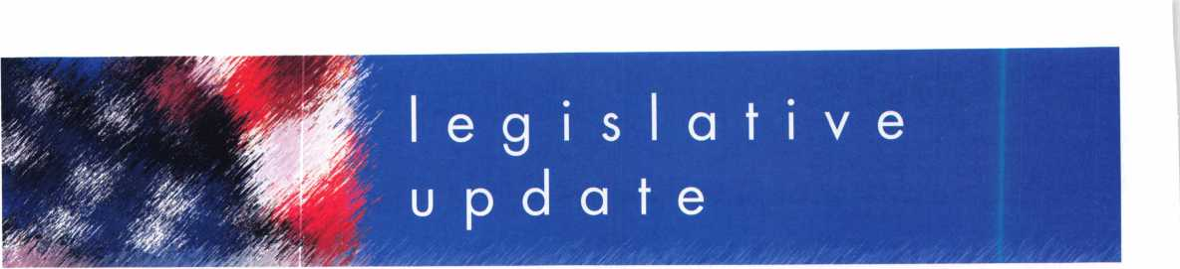

**ALOA LEGISLATIVE REPORT** (As of March is, 2007)

**CT HB 7268**

SPONSER: Public Safety &

Security

TITLE: An Act Requiring the Registration of Electronic Security Alarm Companies ABSTRACT:

To require that electronic security alarm companies register with the Department of Consumer Protection, and to require that all employees of such companies sub­mit to criminal history records checks or comprehensive back­ground checks. Definition includes access control.

STATUS:

* 02/23/2007 Introduced
* 03/12/2007 Favorable Change of Reference, House to Committee on Judiciary
* 03/13/2007 Favorable Change of Reference, Senate to Committee on Judiciary

**HI HB 188**

SPONSER: Evans TITLE: Locksmiths ABSTRACT:

Requires licensing for locksmiths. STATUS:

* 01/19/2007 Introduced and Pass First Reading.
* 01/22/2007 Referred to Consumer Protection Committee

**HI HB 423**

SPONSER: Herkes TITLE: Motor Vehicles ABSTRACT:

Requires motor vehicle manufactur­ers to allow registered owners through a registered locksmith to access information necessary to produce replacement keys.

STATUS:

* 01/19/2007 Pending introduc­tion.
* 01/22/2007 Introduced and Pass First Reading
* 01/22/2007 Referred to Consumer Protection Committee

**HI SB 1011**

SPONSER: Taniguchi TITLE: Motor Vehicles ABSTRACT:

Requires motor vehicle manufactur­ers to allow registered owners through a registered locksmith to

access information necessary to produce replacement keys.

STATUS:

* 01/24/2007 Referred to Consumer Protection Committee
* 02/27/2007 PASSED with Amendments
* 03/06/2007 Received in House with amendments
* 03/08/2007 Passed First Reading
* 03/09/2007 Referred to Consumer Protection Committee

**KY HB 481**

SPONSER: D. Graham

TITLE: AN ACT relating to motor

vehicles.

ABSTRACT:

Create a new section to prohibit any person from producing an ignition key or other device designed to operate a lock on a motor vehicle or start a motor vehicle for any person on the basis of a motor vehicle identifica­tion number (VIN) without obtain­ing and making a record of proof that the person requesting the igni­tion key or other device is the owner or lessee of the motor vehi­cle or is a member of the same household as the owner or lessee of the vehicle.

STATUS:

* 02/14/2007 Introduced in House
* 02/20/2007 Sent to Transportation Committee

**MD HB 903**

SPONSER: Davis, Impallaria, N. King, Montgomery, Myers, and Taylor

TITLE: Vehicle Laws - Consumer Access to Replacement Key Information ABSTRACT:

Requiring a manufacturer of a motor vehicle sold or leased in the State on or after January 1, 2010, to implement a system for provid­ing specified replacement key information to registered lock­smiths; requiring a motor vehicle manufacturer to make a specified key replacement system available to registered motor vehicle owners or lessees 24 hours a day and 7 days a week; establishing proce­dures for a registered locksmith

and a motor vehicle manufacturer to follow to provide a replacement key to a motor vehicle owner or lessee; etc.

STATUS:

* 02/09/2007 H First Reading Economic Matters
* 02/26/2007 Hearing sched­uled 3/8 at 1:00 p.m.

**MD SB 707**

SPONSER: Hooper, Forehand, and Munson

TITLE: Vehicle Laws - Consumer Access to Replacement Key Information ABSTRACT:

Requiring a manufacturer of a motor vehicle sold or leased in the State on or after January 1, 2010, to implement a system for provid­ing specified replacement key information to registered lock­smiths; requiring a motor vehicle manufacturer to make a specified key replacement system available to registered motor vehicle owners or lessees 24 hours a day and 7 days a week; establishing proce­dures for a registered locksmith and a motor vehicle manufacturer to follow to provide a replacement key to a motor vehicle owner or lessee; etc.

STATUS:

* 02/02/2007 S First Reading Judicial Proceedings
* 02/07/2007 S Hearing 3/8 at 1:00 p.m.

**MT SB 153**

SPONSER: Cocchiarella TITLE: Revise professional and occupational licensing laws ABSTRACT:

Bill originally changed definition of "Security alarm system" to mean, "an assembly of equipment and devices or a single device, designed or a portion of a system intended to detect or signal or to both detect and signal unautho­rized intrusion, movement, or crim­inal acts at a location. AMEND­ED to provide for an exemption under "electronic security compa­ny" reading, "The term does not include a person whose primary business is that of a locksmith and who may also install closed circuit television cameras and battery-

operated door devices"

STATUS:

* 01/18/2007 Hearing
* 02/02/2007 Amended
* 02/06/2007 Transmitted to House
* 03/08/2007 Referred to House Business and Labor Committee
* 03/09/2007 Hearing sched­uled for 03/16/2007

**NJ A 2520**

SPONSER: Johnson, Gordon M. TITLE: Concerning electronic secu­rity systems and amending P.L.1962, c.162.

SUMMARY:

This bill exempts businesses which install service or maintain access control systems, closed circuit tele­vision systems or intercom systems from licensure by the Board of Examiners of Electrical Contractors. Under current law, locksmiths, burglar alarm, fire alarm and electronic security busi­nesses, and their employees, are licensed and regulated by the board. This bill changes the defini­tion of "electronic security system" contained in the law so that it does not include access control systems, closed circuit television systems or intercom systems. STATUS:

* 02/09/2006 Introduced, Referred to Assembly Regulated Professions and Independent Authorities Committee

**NJ A 4041**

SPONSER: Chatzidakis, Larry TITLE: Concerning certain lock picking tools ABSTRACT:

Establishes penalties for manufac­ture, purchase or possession of "bump keys."

STATUS:

* 02/26/2007 Introduced, Referred to Assembly Law and Public Safety Committee

**OH HB 41**

SPONSER: Uecker, McGregor, J., Stebelton, Brown, Flowers, Fende, Wagoner

TITLE: Security System Company

Licensing Law

ABSTRACT:

Keynotes • April 2007

To require the licensure of persons operating security systems compa­nies (which includes locksmithing), to provide for the registration of individuals performing specified types of security systems work, and to establish the Security Systems Advisory Board in the Department of Commerce.

STATUS:

* Not available at this time

**OK HB 1845**

SPONSER: Collins TITLE: Crimes and punishments; making certain acts unlawful; cod­ification; emergency.

ABSTRACT:

An Act relating to crimes and pun­ishments for possession of "bump keys".

STATUS:

* 02/05/2007 Authored by Representative Collins
* 02/06/2007 Second Reading referred to Judiciary and Public Safety

**OK SB 26**

**(Same as HB 1054)**

SPONSER: Jolley

TITLE: Professions and occupations and the Alarm and Locksmith Industry Act; deleting an exemp­tion. Effective date SUMMARY:

Exempts the sale, installation, serv­ice, or repair of alarm systems by individuals licensed pursuant to the Electrical Licensing Act under the Alarm and Locksmith Industry Act.

STATUS:

* 02/05/2007 Authored by Senator Jolley
* 02/06/2007 Second Reading referred to Business and Labor
* 02/06/2007 Pending author­ship Representative(s) Cooksey

**OK SB 632**

SPONSER: Barrington TITLE: Professions and occupa­tions; changing the Alarm and Locksmith Industry Act to the Alarm Industry Act. Emergency. ABSTRACT:

An Act relating to professions and occupations by amending the Alarm and Locksmith Industry Act by removing all reference to "lock­smith".

STATUS:

* 02/05/2007 First Reading
* 02/06/2007 Second Reading referred to Business and Labor

**SC H 3104**

SPONSER: Umphlett TITLE: Locksmith Licensing SUMMARY:

Provide for the licensure of lock­smith agencies, to require employ­ee registration, to require signed work order forms when opening residences, commercial establish­ments, and motor vehicles, and to provide penalties for certain viola­tions.

STATUS:

* 01/09/2007 House Referred to Committee on Labor, Commerce and Industry

**SC S 338**

SPONSER: Reese

TITLE: Tampering of a Security

Device

ABSTRACT:

To create an offence of tampering with, altering, damaging, or destroying a security device. Defines a security device to include alarm systems including, but not limited to, burglar alarms and other types of intrusion alarms or access control systems.

STATUS:

* 01/26/2007 Senate Referred to Subcommittee: Hutto (ch), Jackson, Knotts, Bryant

**TN HB 415**

SPONSER: Coleman TITLE: Locksmith Licenses ABSTRACT:

Repeals locksmith licensing provisions.

STATUS:

* 02/07/2007 Introduced
* 02/08/2007 Held pending Amendment

**TN HB 416**

SPONSER: Coleman TITLE: Locksmith Licenses ABSTRACT:

Requires the commissioner of com­merce and insurance to maintain a registry of current locksmiths and any disciplinary actions against them on the department's Web site.

STATUS:

* 02/07/2007 Introduced
* 02/08/2007 Held pending Amendment

**TN HB 1982**

SPONSER: DuBois

TITLE: Exemption from Licensure

ABSTRACT:

Exempts from licensure part-time locksmiths who earn less than $3,000 annually from providing locksmithing services.

STATUS:

* 02/15/2007 Introduced
* 03/06/2007 Assigned to sub­committee

**TN SB 515**

SPONSER: Tracy TITLE: Locksmith Licenses ABSTRACT:

Requires the commissioner of com­merce and insurance to maintain a registry of current locksmiths and any disciplinary actions against them on the department's Web site.

STATUS:

* 02/08/2007 Introduced
* 02/12/2007 Referred to Commerce Labor and Agriculture Committee
* 02/28/2007 Action Deferred in Committee to 03/21/2007

**TN SB 516**

SPONSER: Tracy TITLE: Locksmith Licenses ABSTRACT:

Repeals locksmith licensing provi­sions.

STATUS:

* 02/08/2007 Introduced
* 03/15/2007 Placed on Government Operations Committee Calendar for 3/21

**TN SB 2311**

SPONSER: Bunch

TITLE: Exemption from Licensure

ABSTRACT:

Exempts from licensure part time locksmiths who earn less than $3,000 annually from providing locksmithing services.

STATUS:

* 02/22/2007 Introduced
* 02/26/2007 Referred to Commerce Labor and Agriculture Committee

**TX HB 2295**

SPONSER: Driver TITLE: Relating to a requirement that certain motor vehicle manu­facturers provide key codes and other vehicle access information to registered locksmiths ABSTRACT:

Relating to a requirement that cer­tain motor vehicle manufacturers provide key codes and other vehi­cle access information to regis­tered locksmiths.

STATUS:

* 03/01/2007 Filed
* 03/08/2007 Referred to House Committee on Law Enforcement

**TX SB 1371**

SPONSER: Carona TITLE: Relating to a requirement that certain motor vehicle manu­facturers provide key codes and other vehicle access information to registered locksmiths ABSTRACT:

Relating to a requirement that cer­tain motor vehicle manufacturers provide key codes and other vehi­

cle access information to regis­tered locksmiths.

STATUS:

• 03/07/2007 Filed

**WA HB 1001**

SPONSER: Lovick

TITLE: Combating auto theft.

SUMMARY:

Makes it a crime to possess a "motor vehicle theft tool" with the intent to commit a crime. Motor vehicle theft tool is defined as, "Slim jim, false master key, master purpose key, altered or shaved key, trial or jiggler key, slide ham­mer, lock puller, picklock, bit, nip- er, any other implement shown y facts and circumstances that is intended to be used in the com­mission of a motor vehicle related theft, or knowing that the same is intended to be so used.

STATUS:

* 01/10/2007 Introduced
* 03/13/2007 Passed House
* 03/15/2007 Sent to Senate, first reading. Sent to Judiciary Committee

**WA HB 2243**

SPONSER: Quail

TITLE: Addressing the replacement of motor vehicle keys.

ABSTRACT:

Requires that a motor vehicle man­ufacturer of a new motor vehicle sold or leased in this state after December 31, 2008, shall pro­vide the registered owner of the motor vehicle, through a regis­tered locksmith, information neces­sary to permit the production of a replacement key or other function­ally similar device by the regis­tered locksmith that allows the reg­istered owner of the motor vehicle to enter, start, and operate the motor vehicle.

STATUS:

* 02/14/2007 First reading and referred to Commerce & Labor

**WA SB 5038**

SPONSER: Eide

TITLE: Combating Auto Theft

ABSTRACT:

Commission of a burglary or motor vehicle theft, this act adds the following language, "It shall be prima facie evidence of circum­stances evincing an intent to use for commission of a burglary or motor vehicle related theft for a person to be in possession of mul­tiple vehicle keys or altered vehi­cle keys unless such person is a bona fide locksmith."

STATUS:

* 01/08/2007 First reading, referred to Judiciary.

Keynotes • April 2007

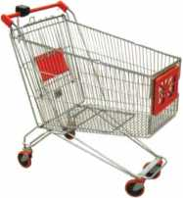

keynotes

Buyer's



**SAFE CORPORATION**

I&T**0**J ELECTRONIC SAFES  
FROM A & B

**product-' Battery powered**

m Digital key pad and  
credit card actuated

r?



RS-10

RS-5

800-253-1267

114 S. Delsea Drive, Suite 3 856-863-1186

Glassboro, NJ 08066 Fax 856-863-1208

Punch SARGENT blanks to factory specifications.

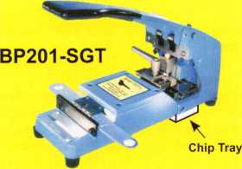

Available Exclusively from:

**Locksmithing, Uni. LLC  
302-575-0993  
[www.sargentpunch.com](http://www.sargentpunch.com)**

|  |  |
| --- | --- |
|  | STOP! |
| OAST SA** | Using a general purpose |
|  | lubricant? Be professional! Use a specially formulated |
| iSRICAN | lubricant for the Locksmith |
| - * aw. | and Safe Technician trade. |
|  | You and your customers will |
|  | be well pleased. Guaranteed! |

$48°° + shipping per case.

12 -1 loz. cans per case minimum order.  
Order via phone or fax. Credit cards accepted.  
Net 30 W.A.C. or send check with order.

Coast Safe & Lock Co., Inc.

P.O. Box 66257 • Mobile, AL 36606  
(251) 479-5264 • Fax (251) 471-6967

Keynotes • April 2007

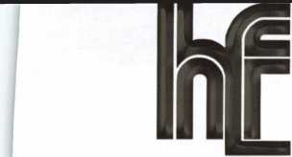

**BUMP KEYS ...**

**NEED A HANDOUT EXPLUNINfi DAMPING?**

Bumping has become a hot topic in the news lately,  
and your customers might have questions for you...

Let HL Flake’s “Bump Key” Postcards  
help educate your customers!

**THESE POSTCARDS WEI...**

* **Answer questions about bumping**

**• Provide solutions  
• List the facts**

**RECEIVE 100 POSTCARDS FREE!**

**WITH YOUR NEXT $250 ORDER**

***\*MENTION COUPON CODE “BUMP 100” WITH YOUR SALES REP***

* ***LIMIT - ONE FREE SET PER CUSTOMER***

**Full color postcards are ideal for mailing to your customers,  
leaving on your shop counter, or handing out on service calls.**

***Additional postcards available* @ a *very LOW price!***

***Call for details 800-231-4105***

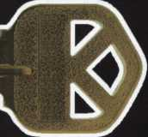

Since 1912

The Locksmith Supplier

800-231-4105



Since 1912

The Locksmith Supplier

800-231-4105

**RING of a KING**

|  |  |  |  |
| --- | --- | --- | --- |
| Member Name Sponsorship: | s | Ronald E. Heidzig | ....18 |
|  |  | Joe J. Lee CRL | ....18 |
| Kwok-kei Leung | 223 | Peter R. Hall | ...17 |
| Toshihiro Asano | 119 | Eugene R. Altobella Jr | ...17 |
| Henry W. Raymond | .92 | Kenneth E. Kim CRL, CPS | ...16 |
| Yuriko Yanai | .82 | Joseph W. Whitaker CPL | ....16 |
| David M. Troiano | .69 | John A. Ilk CRL, CPS | ....16 |
| Mary S. Ohmit CPL | .66 | Evelyn V. Wersonick CML, CPS .... | ....15 |
| William Lee CRL | .66 | Joseph P. Ferrero CML | ....15 |
| Charles C. Robertson CML | .65 | John W. Soderland CML, CMST.... | ....15 |
| Clifford D. Lipscomb CML, CPS | .63 | Michael E. Jordan Jr, CML | ....15 |
| Michael B. Groves | .57 | John J. Greenan CML, CPS | ....15 |
| Jack Hobin CPL | .51 | Brian J. Reetz | ....15 |
| William B. Neff CML CPP PSP | .48 | Richard C. Sievers | ....15 |
| Ken Dale | .46 | Steve L. Cothron | ...15 |
| Jim Williams CRL | .44 | Leonard J. Passarello CPL | ...14 |
| C Allan Halverson | .40 | Gary F. Teams CPL | ....14 |
| Myeong-Rae Cho | .38 | John D. Cannon CML | ...14 |
| David M. Lowell CML, CMST | .37 | Timothy J. Moore CRL | 14 |
| Salvatore J. Dulcamaro CML | .36 | Gregory L. Perry CML, CPS | 14 |
| Dana L. Barnum CML | .35 | Paul M. Souber | 14 |
| Barry K. Leas CRL | .35 | James T. Brickler CML | 14 |
| Hans Mejlshede CML | .34 | John F. Engel CRL | 14 |
| Peter Sarailian CRL | ..33 | Charles E. Batcke CRL, CPS | 14 |
| Scott L. Henke CPL, CPS | .33 | Robert C. Rodocker CPL | 13 |
| William L. Young CML, CPS | .33 | Calvin G. Harris CML | 13 |
| Robert D. DeWeese CML, CPS | ..33 | Robert E. Mock | 13 |
| Danny W. Rudd CPL | ..32 | Rolando Bouza | 13 |
| William T. Beranek | .32 | Barry L. McMenimon CPL | 13 |
| James L. Hancock CPL | ..32 | Basil W. Shannon CPL | 12 |
| Larry A. Warnick CML | ..31 | William J. Wickward CML | 12 |
| Robert W. Duman Sr, CML | ..31 | Bruce J. Tarbet CML, CPS | 12 |
| Eugene R. Altobella Sr | ..31 | Robert M. Massard CRL,AHC | 12 |
| John C. Elliott Jr, CML, CPS | ..30 | Thomas Demont CML, AHC | 11 |
| Dallas C. Brooks | ..28 | J Casey Camper CML, CPS | 11 |
| Breck H. Camp CML | ..27 | Gordon R. Racine CML | 11 |
| Lawrence F. Smith Jr, CML | ..27 | Bruce P. Eagan CML | 11 |
| Marian M. Swann CRL | ..27 | Todd K. Ladwig CML, CPS | 11 |
| James M. Watt CML, CPS | ..27 | Kevin R. Wilson CML, CPS | 11 |
| Philip A. Rovenolt CPL | ..27 | Carroll T. Mann | 11 |
| John L. Shandy CML | ..26 | Dana L. Lee CML | 11 |
| Jeffrey S. Nunberg CML, CMST.... | ..26 | Andrew A. Edmunds CML, CPS ... | 11 |
| J Thomas Hood CML | ..26 | Maurice R. Horne CML | 11 |
| Elvis D. Hammerschmidt CPL | ..25 | Daniel S. Enriquez CRL | 11 |
| Anthony J. Ramunno CML, CPS .... | ..24 | Dale L. Knowles | 11 |
| Takashi Kuwana CRL | ..24 | Charles E. Haas CML | 10 |
| Man-Soo Seo RL | ..23 | Lester S. Brodsky | 10 |
| Jerome L. Cohen CML | ..22 | Ralph O. Warren CML | 10 |
| Peter K. Gauthier CPL, CPS | ..22 | Thomas R. Smith CPL | 10 |
| Michael C. Olson CRL | ..21 | Timothy K. Chow | 10 |
| John S. Dorsey CML, CPS | ..20 | Richard T. Johnson CPL | 10 |
| James J. Cawby CML, CPS | ..20 | Raymond C. Lusk CML | 10 |
| William P. Grant CRL | ..20 | Vincent L. Formon CML, CPS | 10 |
| Walter W. Lascar Sr., RL | ..19 | Carroll T. Croson Jr | 10 |
| Thomas G. Vandersteen CML, CPS.. 19 | | David M. Howdle | 10 |
| Ernest W. Wright | ..18 | Kenny R. Carroll | 10 |
| James E. Gruber CPL | ..18 | Gene Eldridge | 10 |
| William J. McElheney CML | ..18 | Larry L. Votaw CML | 10 |
| James E. Fowler Sr, CML | ..18 | Andrew S. Dennison CPL, CPS | 10 |

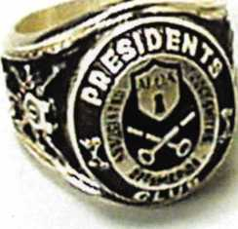

How can I join the President's Club?

You can earn a membership in this prestigious club by recruiting  
just 10 new members for ALOA.

*Any ALOA member may participate.

What do I get?

When you recruit 10 members, you receive a  
handsome blue blazer with a President's Club crest.

You also get the satisifaction of knowing that you are  
helping your association, helping your industry grow,  
and you are helping fellow locksmiths achieve success.

How do I get started?

Mail the form below to the ALOA office for a supply of  
applications (800) 532-ALOA or FAX (214) 819-9736.  
One President's Club credit is awarded for each new  
applicant. Credit is awarded only after the membership  
application is approved. However, the credit will apply  
for the period in which the application is received.  
Failure to identify yourself as the sponsor on the applica-  
tion form at the time it is submitted to ALOA for process-  
ing will forfeit any credit.

|  |  |
| --- | --- |
| Yes! 1 want to join the ALOA President's Club.  Please rush me applications so 1 can start earning credit toward membership in the club! | |
| Name |  |
| Company |  |
| Address |  |
| City | State Zip |

Mail this form to ALOA • 3500 Easy St. • Dallas, Texas 75247-6416

Craft

your own career

in Locksmithing

Learn to be a locksmith at our conveniently  
scheduled hands-on morning program. Classes  
are given from 7:30 am - 12:30 pm. Over nine  
months you will learn to service, install and  
bypass a wide variety of locking devices including

residential, commercial and automotive locks. Master keying, electronic  
access, and safe manipulation round out a curriculum which is updated  
annually to incorporate the latest industry advancements. September and  
February admissions.

Other full-time courses offered are • Bookbinding • Cabinet & Furniture Making • Carpentry • Preservation Carpentry • Jewelry Making & Repair • Piano Technology • Violin Making & Repair

Financial aid is available for qualified students. Accredited member ACCSCT. Non-accredited workshops 1 week to 3 months also offered.

NORTH-BENNET-STREET-SCHOOL

AN EDUCATION IN CRAFTSMANSHIP 39 North Bennet St. • Boston, MA 02113 • (617) 227-0155

[www.nbss.org](http://www.nbss.org)

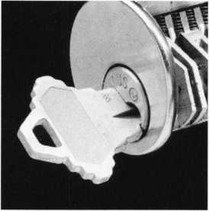

mrnnn

ssssw

EASTER I LOCK & KEY JB

k 325-3535 /

**USDVA**

**ILLINOIS**

A-1 KEY & LOCK  
24HR SERVICE  
312-555-1234

DUP JCATION PROHIBITED

**Smart Clone**

**For All Cloneable Keys... including Ford, Infiniti & Toyota**

**Smart Clone Key Blanks**

**Professional Products for Professional Locksmiths**

**Largest Selection of Groovy Keys Anywhere**

**Displays and Key Assortments**

**Precision Key Machines and Cbtters**

**250 Bin Packs**

**View Our Complete Line of Professional Locksmith Hardware at**

**[www.jetkeys.com](http://www.jetkeys.com)**

**Jet**

**Exclusives**

**Uni Bow Neuter Bow Personal Line**

**JET HARDWARE MANUFACTURING CORP**

**800 Hinsldale Street, Brooklyn NY 11207**

|  |  |
| --- | --- |
| 1  1 | ill |
| Automotive |  |
| Transponder |  |
| Keys |  |

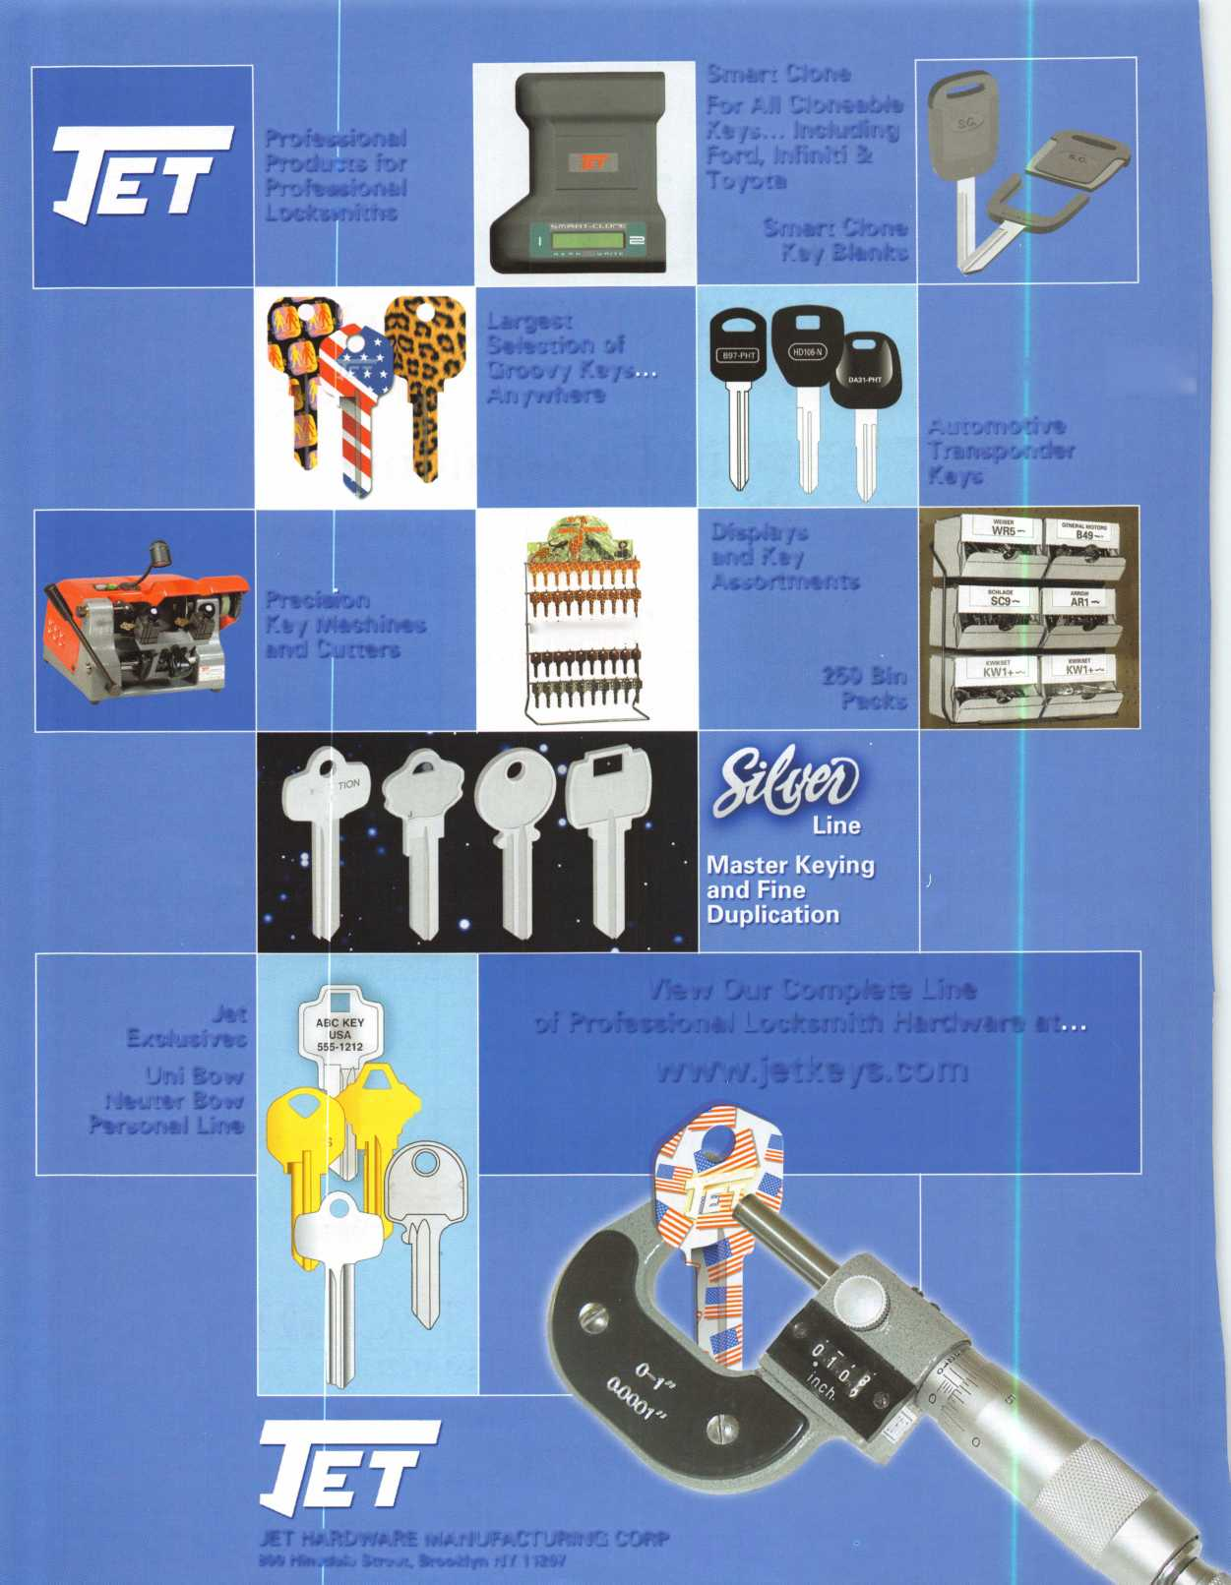

Door Jamn Armor Stop Giving Away Your Profits!

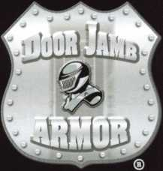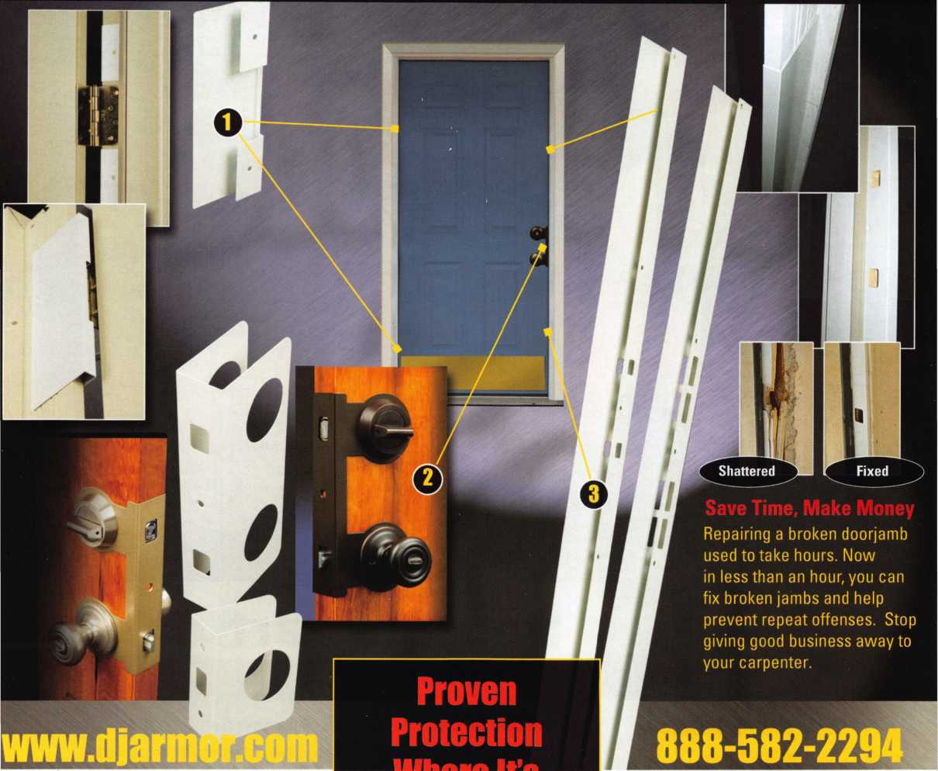

E Hinge Shield

e Hinge Shields fit around the existing or hinges and help prevent hinges from ing kicked in

I Door Shield

e Door Shield reinforces the lock area of i door and helps prevent the door from litting when kicked. Low profile model available in colors to match your locks

> Jamb Shield

e backbone of the system, the Jamb lield is a 48" long sleeve that wraps ound the lock side of the doorjamb, aking it extremely difficult to kick in. le Jamb Shield comes sizes to fit andard (5.5") and Universal (5" to 12")

:k spacing. Jamb and hinge shields

onrn +r» o+nrl iA/i+h Q 1/5” o r> mi a /o /mnli irln rl \

Your Customers Need This

Current security products only alert homeowners that they have already been violated.

Your customers will actually be able to sleep secure the night after a break-in. Helps eliminate tenant initiated damage and secures vacant units for landlords.

This Will Change Your Business

* You should make $1,000 on every call that you answer with this product
* Calling a carpenter to fix shattered jambs costs you money
* This will help you sell more high-end deadbolts

**mine ii a**

Needed Most

**A unique system that  
reinforces the key strike  
points on entry doors  
and repairs damage  
from previous kick-ins**

**Because Ytou Can’t Afford Falsa Security ®**

* fin \/n11 work with anu lanrllnrrk?

**SearchAlert**

* Available in a variety of colors and styles
* Recognized & Accepted by the TSA
* Security Window cannot be altered with a paper clip
* Security Window can only be reset by a person knowing the combination
* Zinc Die Cast Body (Not Brittle Plastic)
* Steel Shackle is virtually unbreakable

Security Window

O

**Red Window:**

Luggage has been searched.

O

**Green Window:**

Lock Not Opened.

The new SearchAlert Security window changes color from Green to Red when the TSA secured access device is used to open the lock, or when an unauthorized person has opened the lock using a counterfeit opening device. Travelers will now know when their SearchAlert Classic locks have been opened, and whether their bags have been searched by a TSA agent, or violated by an

unknown person. Protected by U.S. Patents 6,877,345 and 7,007,521. The Design of the Lock is a Registered Trademark® of The Eastern Company.

***The name you can Trust for Travel safety, security*** & ***accountability.***



**Security Products A** Division of The Eastern Company **A Proud Union Company. (S.E.I.U.)**301 West Hintz Road | Wheeling, IL 60090 | Telephone: 800.733.8588 | Fax: 847.537.1881  
**[www.cclsecurity.com](http://www.cclsecurity.com)**

**TRAVEL SENTRY**

**APPROVED**

